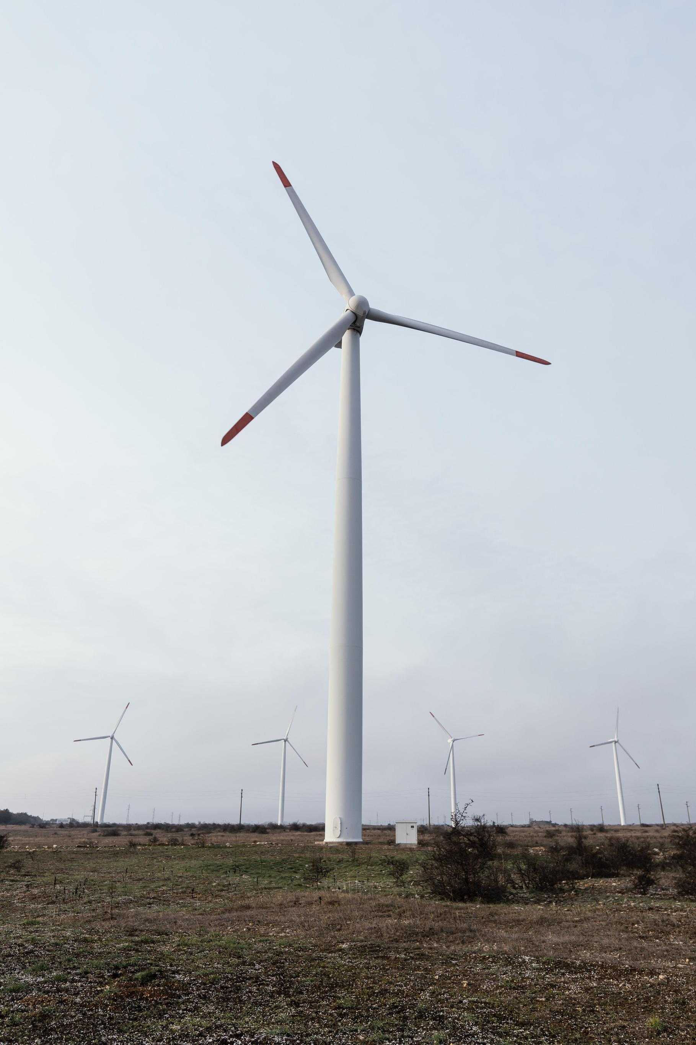



Hyber H-Savonius VAWT
Wind Turbine

G10/S2--2025
Group: 17111

Team Crew

Bavly Nady
Bavly.1724014@stemismailia.moe.edu.eg

Mohamed Mohsen
Mohamed.1724038@stemismailia.moe.edu.eg
Peter Fayez
peter.1724048@stemismailia.moe.edu.eg

Youssef Yehia
Yousef.1724060 @stemismailia.moe.edu.eg
Ziad Hossam
Ziad.1724062@stemismailia.moe.edu.eg

Table of contents

Introduction
Chapter I.
CHAPTER I
Present and Justify Solution Requirements:

- Egypt Grand Challenges. ……………………………….pg.5-pg.17

- Problem to Be Solved. ………………………………….pg.17-pg.19

- Research. ……………………………………………….pg.19-pg.59

- Other Solution Already Tried. …………………...…….pg.59-pg.63
Chapter II.

Generating and Defending a Solution:

- Solution and Design Requirements………………..…….pg.65-pg.68

- Selection of Solution. ...……………………………..…..pg.69-pg.71

- Selection of Prototype ……………………...……..…..pg.71-pg.72
Chapter III.

Constructing and Testing a Prototype:

- • Materials and Methods. ……………………..………….pg.74-pg.75
- • Test Plan. ……………………………………………….pg.75-pg.77
- • Data collection ………………………….………..…….pg.77-pg.78
Chapter IV.

Evaluation, Reflection, Recommendations:

- Analysis and Discussion. …………….……………….pg.80-pg.82
- Recommendations. ………………………….…..…….pg.82-pg.83
- Learning Outcomes. …………………………….…….pg.84-pg.86
- List of Sources in APA Format. …………………..….pg.87-pg.89

Introduction

Earth is a wonderful planet, from super tall mountains like Everest to the deepest places in the oceans, the Mariana Trench, at about 12.3 miles! -at everything it’s a beautiful wonderful one, but unfortunately earth begin into Destruction and decline processes and all of this ruin due to the human beings bad and outsmarted activities and plans in every procedure to the future without taking in consideration that it’s our home or there is another creatures like animals living with us within this plant, not even taking in consideration that another people will came after us live where we was. From here, every authority must make decisions and take effective steps towards changing and protection, but here are some: stop! To what? How do we say the Earth is in a dangerous situation, and from what?

Here we begin with our dear, in Egypt. We know that Egypt suffers from the presence of main grand challenges that can be changed upside down from taking one step forward to those and take into consideration the spinal cord of Egypt, which is the renewable energy, and how this important note is important in solving the following grand challenges, and to the Egyptian renaissance.

- Pollution
- Improving the sources of clean water
- Improve the use of arid areas
- Reduce the urban congestion
- The population growth and its consequences
- Improve the usage of alternative energies
- Increasing the industrial and agricultural bases
- Reduce and adapt to the effects of climate change
- Increase opportunities for Egyptians to work

We will now talk about every challenge and illustrate everything about it.

We will also try to solve each challenge and about how we reach this solution by researching to get all the scientific bases to get the perfect solution.



CHAPTER I

Present And Justify
The Problem

Egypt grand challenges
Egypt has been dealing with lots of challenges lately, and this has been making Egypt, stop multiple times from developing, furthermore, this has been making damage to several aspects, starting from economic, reaching something like health, by solving those grand challenges, Egypt, would get a chance to develop, and improve aspects that would make people’s life more and more better. For this capstone project, there were four grand challenges from the eleven chosen, and this project will solve them:

1. Improve the use of alternative energy
2. Improve the scientific and technological environment for all
3. Address and reduce pollution in air, water, and soil
4. Reduce and adapt to the effects of climate change

Improve The Use Of Alternative Energy :-
4

Overview)-
Egypt suffers from the use of conventional energy, going up to 88.5% fossil fuels energy (2022 est.), which is very high, and it is harming the environment more and more, and using only 11.4% renewable energy as shown in the Table.1.1
Source | Percentage
Solar | 2.1%
Wind | 2.9%
Hydroelectricity | 6.2%
biomass and waste | 0.2%
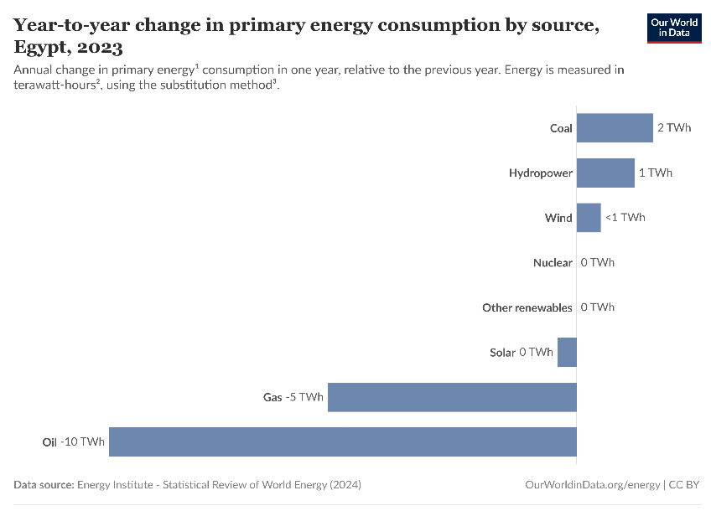
Table.1.1: Renewable Energy Use In Egypt (2022 est.)

Although, Egypt has a phenomenal land with sunny weather and high wind speed, making it a prime location for renewable energy projects. But Egypt has been using fossil fuels till now a lot more than renewable energy.
Figure 1: Annual Energy Consumption In One Year

As shown in Figure.1, Egypt has been driven towards oil more than any renewable energy source with a total of 10 TWh in only one year, which indicates that Egypt is having trouble with renewable
energy sources, as it is going back as shown in Figure.1.

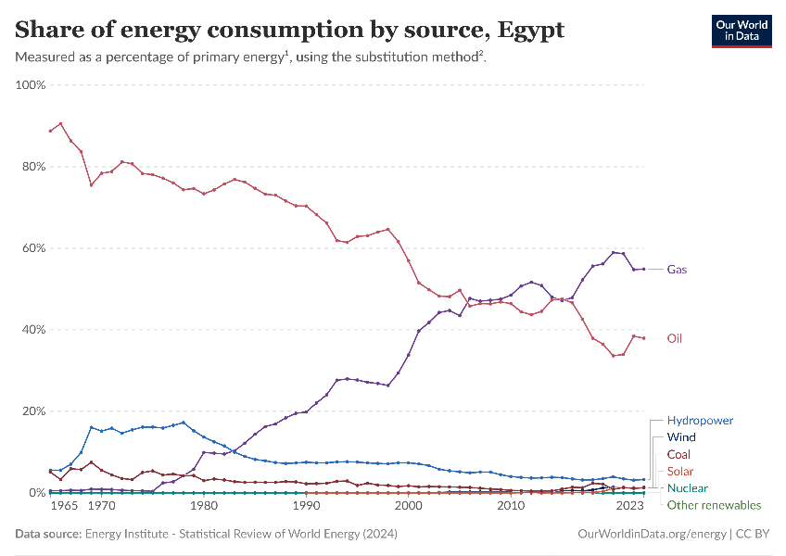
The consumption of those energy sources was going back until 2021 it went up again until 2023, 6% of the energy consumption in Egypt. So Egypt is trying to solve the problem and reach the maximum energy consumption of renewable energy and get rid of conventional sources such as oil. And something like solar energy is going up reaching 1.4% of energy consumption, if those alternative energies sources are replaced with conventional sources there will be less or even no effect on the
Figure 2: Share of energy consumption
environment, and that what is Egypt is trying to do based on the data provided by Figure.2, which indicates that the oil and gas consumption is going down and alternative sources such as solar and wind is going up and are getting used more and more in Egypt's grid.

causes)-

Image 1
Renewable energy may be a great replacement for conventional energy, but it still faces major obstacles that face any country with the willingness to change from conventional based energy to renewable based ones.

Initial Cost

Foremost the obvious reason for this is the cost, or the expense of building and installing solar and wind farms. As most of the renewable
energy sources, its fuel is too cheap to operate, and its maintenance is genuinely minimal, so the bulk of the cost comes from installing the technology in real life. The average cost in 2017 to install solar system is ranging from $2000 per kilowatt to almost $3700, in the other hand a new natural gas plan might have cost around $1000 per kilowatt, so every country just thinks about the initial cost, and ignore the long term benefits, this barrier stands in front of countries which are about to build a new solar or wind farm perceive renewable energies as risky, as the initial investment for it is very high.

Reliability On Misconceptions
Moreover, the reliability on misconceptions also play a role as an obstacle, as the myths spread fast enough, and opponents to renewable energy tend to highlight the variability of sun and wind as a way to stop this development, and support for coal, gas and nuclear plants, which can more easily operate on-demand or provide continuous power, but in reality it is much better than those conventional sources as solar and wind are highly predictable, and when spread across a large geographic area, and paired together it becomes more reliable.

Conversion Efficiency


Furthermore, the efficiency of
Image 2
converting different renewable
energy to electric energy is low, as
each type of energy requires a
specific technology so that it
could be converted into
electricity, the efficiency of this
energy conversion process is
important when prioritizing
energy sources. Unfortunately,
the efficiency of renewable technology is
not that high compared with traditional energy
conversion efficiency

Impacts
This problem has led to many impacts, making harm on the climate, environment and even political conflicts. Making this a dangerous and must solve problem in Egypt.

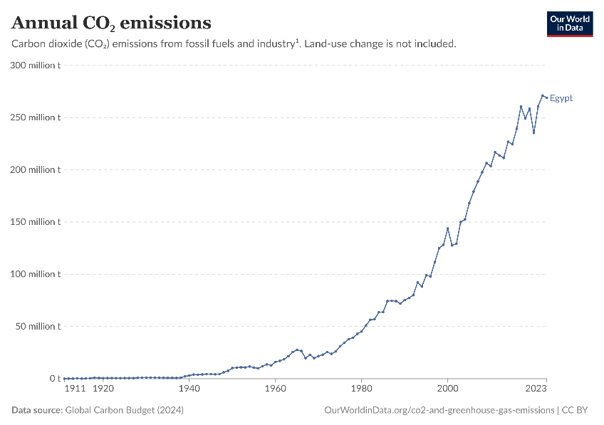
Climate Change
Figure 3: Annual CO2 Emissions
The lack of use of renewable energy causes more use of conventional sources and burning something, such as fossil fuels releases carbon dioxide and other greenhouse gases into the atmosphere, contributing to global warming and climate change. As show in Figure.1.5 the emission of CO2 is increasing and causing damages across Egypt and across the world overall

Habitat destruction

While extracting non-renewable sources of energy it could lead to habitat destruction and loss of biodiversity, this could happen from
Image 3
activities such as mining and drilling which can have a significant impact on local ecosystems. As shown in Figure.1.6, many habitats get
destructed that way, and animals stand still, soon they will all become extinct, and biodiversity will be lost.

Foundation Of Political Conflict
As the use of fossil fuels is growing, and knowing that fossil fuel will end at some point, countries may go to war frequently over access to needed resources, it is not unusual to hear government critics suggest that military action should be taken to gain control over oil or natural gas, and this may happen much more frequently if the world kept on using non-renewable energy sources.

Address & Reduce Pollution in Air, Water and Soil: -

Air Pollution):

Overview)-
Air pollution has been a problem in Egypt for decades, in large cities such as Cairo, which is considered a home for 23 million people in 2020, moreover as the levels of the fine particulate matter PM10 and PM2.5, that have a great risk to people’s heath, are several times higher than the levels that World Health Organization (WHO) recommends. And by this increase of fine particulate matter, people’s health is in danger, as those pollutants have a huge impact on people’s health in which it could cause heart and vascular disease. Also, emissions of carbon-dioxide contribute to the air pollution in Table.1.2, Egypt may not be the worst of all, but it has the highest rate of change across all the world, this means that pollution in air is getting worse and worse.

Countries | 1990 | 1995 | 2000 | 2004 | 2008 | Rate Of Change
America | 4821.2 | 5209.1 | 5961.9 | 6049.4 | 6302.3 | 26.6%
England | 579.7 | 569.6 | 580.1 | 587.3 | 590.2 | 2.05%
Egypt | 75.5 | 95.1 | 138.7 | 158.2 | 170.3 | 141.06%
Morocco | 23.5 | 30.3 | 34.3 | 41.2 | 44.2 | 96.2%
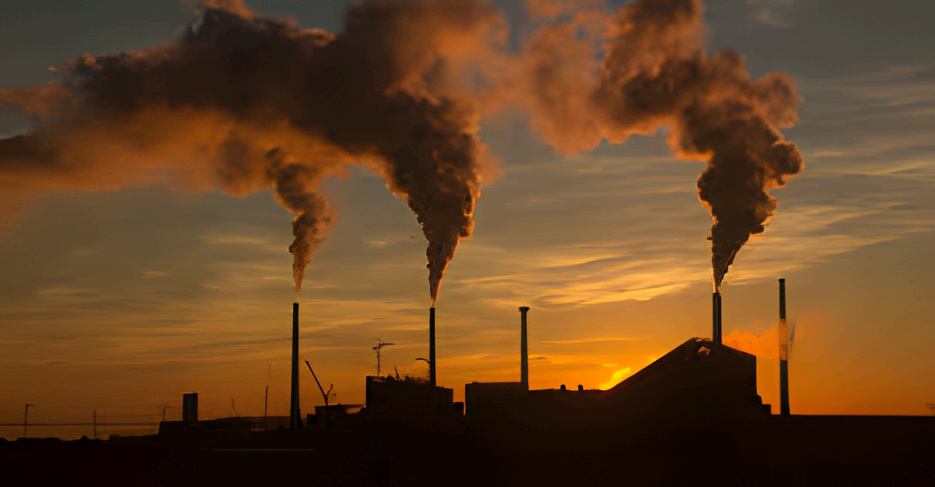
Table.1.2: Carbon-dioxide Emission (2010 est.)
Image 4

Burning Of Fossil Fuels:
In general fossil fuels are formed after decomposition of buried carbon—based organisms that died a million years ago, they are non-renewable and currently supplying 80% of the world’s energy. The Intergovernmental Panel on Climate Change (IPCC), has found that emissions from fossil fuels are the dominant cause of global warming. In 2018, 89% of global CO2 emissions came from fossil fuels and industry. As shown in Figure.1.7, this steam coming out of the factories, they carry lots of CO2 emissions.

Mining Activities:
During the mining activity, and extracting various minerals, the fine particles that are released into this activity may contain heavy metals or other harmful pollutants, and this mining dust can affect air quality, and the respiratory health overall mining could be very harmful to air.

Agricultural Activities:
In recent years, the increase in the consumption of fertilizers has increased, causing serious environmental problems and responsible for an expected increase in N2O (Nitrous Oxide) and NH3 emissions. The NH3 is a gas which could stay in the atmosphere for a few hours, but after mixing with other gases it could form particulate matter (PM) which can exist for several days and cause severe diseases and help in the increase of air pollution.

Impacts)-

Acid Rain:
is made up of highly acidic water droplets due to air emissions, specifically the levels of Sulphur and nitrogen emitted by vehicles and manufacturing. The amount of Sulphur and nitrogen that is flown by a wind undergo oxidation next, and then they react with water resulting in the formation of sulfuric acid and nitric acid as shown in the following equations:
Those acids are very harmful to agriculture, plants and animals, as it could cause some respiratory issues in animals and humans.
Equation 1

2SO2 (g) + O2 (g) + 2H2O (l) → 2H2SO4 (aq)
4NO2 (g) + O2 (g) + 2H2O (l) → 4HNO3 (aq)


Global Warming:
As air quality is getting worse, some greenhouse gases concentrations in the air are rising, so does the global surface temperature, the ocean soaks up most of the heat, although the rate at which the ocean is warming strongly increases over the past two
Image 5

decades, but also its level is increasing, melting ice sheets and increasing the threatened coastal and island communities.

Diseases:
air pollution has resulted in several respiratory disorders and heart disease, especially lung cancer which has been increasing in the last few decades, while children that live near polluted areas are more prone to pneumonia and asthma, causing lots of people dying every year directly or indirectly because of the effects of air pollution.

Water Pollution):

Overview)-
Water pollution occurs when harmful substances--often chemicals or microorganisms--spread into a stream, river, lake, ocean, aquifer, or other body of water, reducing water quality and increasing its toxicity, which has huge harm on humans and environment.

Causes)-

Sewage And Wastewater:
Using water is wastewater, it could be from our sinks, showers and toilets or from any commercial, industrial and agricultural activity. The term also includes storm water that comes from rainfall carries, more than 80% of the world's wastewater flows back into the environment without being treated or reused, according to the United Nations.

Radioactive Substances:
radioactive waste is any pollution that emits radiation beyond what is naturally released by the environment, most of the time it is from uranium mining, nuclear power, and the production and testing of military weapons, as well as some institutes like hospitals that use radioactive materials for research and medicine, all of that could be harmful to the water when it is released into it and may cause severe amount of damage.

Oil Pollution:
Oil is one of the most used energy sources in the world, with that it is one of the most serious causes of water pollution, with an estimated 1 million tons of oil that is making its way into the marine environment each yea, dropping from cars, trucks or even ships.

Impacts)-

Poor Human Health:
Water pollution has a significant impact on human health, leading to a variety of diseases, as water carries harmful chemicals, bacteria and pathogens that can pose serious risks to those who consume or come into contact with the polluted water, as a result individuals may experience a range of health problems, including gastrointestinal issues, respiratory problems and skin infections.

Disruptions In the Food Web:
in an ecosystem, the food chain is a balance between species, and each creature must play its own part in this precise system if something goes wrong it is like a domino effect and all the thing will go wrong, as the primary producer is being killed because of water pollution then the entire chain may fell apart, along with plants dying and messing with other species.

Soil Pollution(:

Overview)-
Soil pollution refers to the contamination of soil increase in toxicity, with the much technology that we have people started to throw more and more radioactive and toxic substance in soil so, soil is getting more and more toxic.

Causes)-

Poor Management or Inefficient Disposal of Waste:
The increasing volume and complexity of waste associated with the modern economy is posing a serious risk to ecosystems and human health. Every year, an estimated 11.2 billion tons of solid waste is collected worldwide, ranging from non-existing collection system to ineffective disposal causes more soil contamination.

Natural Pollution of Soil:
in some extremely rare processes, some pollutants are naturally accumulated in soils this can occur due to the differential deposition of sol by the atmosphere.

Impacts)-

Poorer Harvests:
Soil pollution is causing the soil quality to be less than before, causing many harvests to be poor and sometimes cause them to spoil.

Climate Change:
also soil pollution may cause climate change or help to cause it, since 2015 to 2050, 69 gigatons of CO₂ will be emitted because of land use change and land degradation, so soil pollution is something serious.
- Desertification:
The number of inhabitants in the most arid areas of the earth could account for 45% of the world's population in 2050, while world wetland areas have decreased size by 87% over the last three centuries.

Reduce and adapt to the effect of the climatic change: -

Overview)-
climate change is a long-term change in the average weather patterns that have come to define earth's local, regional and global climates. Changes observed in Earth's climate since the mid-20th century are driven by human activities, particularly fossil fuel burning, which increase heat-trapping greenhouse gas levels in earth's atmosphere.

Causes)-

Volcanic Eruptions:
volcanoes can impact climate change, during major explosive eruptions huge amounts of volcanic gas, aerosol droplets, and ash are injected into the stratosphere, then the ash falls rapidly from the stratosphere, but volcanic gases like Sulphur dioxide can cause global cooling while volcanic carbon dioxide, a greenhouse gas has the potential to promote global warming.

Natural Greenhouse Gases:
some of the infrared radiation from the sun passes through the atmosphere but most is absorbed and re-emitted in all directions by greenhouse gas molecules and clouds the effect of this is to warm the earth's surface and the lower atmosphere, the contribution that a greenhouse gas makes to the greenhouse effect depends on how much heat it absorbs, how much it re-radiates and how much of it is in the atmosphere, in the following list are the most gases that contribute to the greenhouse effect

1-Water vapor 2-Carbon dioxide
3-Nitrous oxide 4-Methane
5-ozone

Deforestation:
is the purposeful clearing of forested land, throughout history and into modern times, forests have been razed to make space for agriculture and animal grazing and to obtain wood for fuel, manufacturing and construction. This process can result in more carbon dioxide being released into the atmosphere, that is because trees take in carbon dioxide from the air for photosynthesis.

Impacts)-

More Droughts and Heat Waves
droughts in the southwest and heat waves are projected to become more intense and cold waves less intense and less frequent, which means less agricultural activity across the country.

Longer Wildfire Season
warming temperatures have extended and intensified wildfire season in the West, where long-term drought in the region has heightened the risk of fires. Scientists estimated that human-caused climate change has already increased the amount for burned forests, by around 2050 the amount of land consumed by wildfires is projected to further increase by two to six times and this is something very dangerous.

Increase In Global Temperatures
the summer of 2023 was earth's hottest summer on record, and this will be something normal every year as the global average temperature is getting high according to NASA this will continue to get even further and cause serious problems such as the melting of ice sheets and the rise of sea level. Which will make arctic to be very likely Ice-Free as this change is expected to occur before mid-century.

Improve the Scientific and technological environment for all

Overview)-
Egypt has spent on scientific research around 0.2% of GDP (Gross domestic product) for nearly 30 years, it is still far below the world average of 1.2%, but it is trying to fund available research to improve and invent technologies in Egypt. To improve the quality of life, and the past quarter-century has witnessed remarkable progress in scientific and research cooperation between Egypt, United States and many others,
publishing over 18,000 papers in the past decade only, ranking the fifth in the world in terms of research paper published but still Egypt isn’t getting the latest technology over the world. Moreover, the information and communications technology (ICT) sector in Egypt is very amazing, and it is developing more and more with a growth rate higher than Egypt’s overall level of GDP growth, as the Egyptian government is undertaking a series of investments, capacity building and training several programs
to help build a new generation of youth that would help and improve the
technological life in Egypt, for instance Egypt has an initiative called “Our Future Is Digital” aiming to train more than 100,000 young Egyptians and develop the ICT skills in areas of high market demand including website design, data analysis, and digital marketing, while also Egypt is supporting STEM (science, technology, engineering, mathematics) education, it seeks to bridge the gap between academia and industry.

Causes)-
The causes of the poor scientific and technological aspect in Egypt, may seem easy to solve, but under the hood it is very hard to solve all these causes, but Egypt is investing more into those causes and willing to end this poor scientific and technological aspect.

1. Insufficient Government and private sector
Egypt remains till now under the average of global average for developed nations as
it has limited financial support from any private sector which decreases the
opportunities of any innovation and industrial research, and that is stopping Egypt
from growth and improving technology more and more.

2. Traveling abroad
Although traveling aboard and sharing science may seem great, but statics show that scientists who travel aboard and leave Egypt searching for better opportunities in other countries, this makes Egypt lack of professional research and scientists leading a very big loss in Egypt’s economy due to insufficient professionals to handle problems

3. Weak industry-academia collaboration
Egypt may have a great amount of scientists who do research papers a lot, but there is a huge gap between those research papers and the application of it on the real world, due to that you may have the structure the idea of a new technology, but Egypt won’t apply it immediately or even soon due to that gap, this is because there are fewer people in Egypt that invest in projects like that, and that makes the quest of the researches harder in Egypt.

Impacts)-
If Egypt couldn’t move soon and improve the scientific and technological
environment for all a huge problem may happen leading to much more negative impacts, starting with the economic growth

1. Limited economic growth
The more Egypt technology is getting worse the more that its economic growth will still get back, as Egypt would need to buy those technologies from the other countries and other countries won’t leave this chance and will exploit Egypt and ask for lots and lots of money this will make Egypt is statue worse and stop it more from improving its scientific aspect

2. Healthcare Innovation challenges
As the population is increasing with an annual growth of 1.6% the human wastes are also increasing reaching 100 million tons in 2019 with a recovery rate of these waste only 12% leading to troubles in health and loss in many great opportunities all of that is because the technology is poor, the lower that Egypt invest in research related to healthcare it will struggle to provide medicine on demand with the cost of treating 2.9 million patients during 2020 is estimated at about 8.9 billion pounds.

3. High dependency on foreign technology
Egypt, like many developing nations, relies heavily on foreign technology to support its industrial, economic and scientific sectors, much of Egypt’s technological progress depends heavily on other countries. Despite efforts that Egypt is doing, this reliance is still there, and it is not only increasing cost, but also limits the country’s ability to compete in global market.

Problem to be solved

A. Overview

Egypt faces numerous obstacles daily, something like the 11 Grand Challenges, including energy insecurity, environmental degradation, and public health risks. While diesel generators are widely used, in areas that have unreliable grid electricity, industrial zones, and during frequent power outages, diesel reliance creates a problem, sure it provides the needed energy, but it increases the long-term vulnerabilities, in too many aspects, like environmental, energy, and health systems, as generators emit harmful pollutants, causing Egypt's transition to sustainable energy to be delayed, if a targeted reduction in diesel generator use would address this systemic issue, and reduce the gaps in energy access, air quality, and economic resilience. And solve more challenges from Egypt’s grand challenges, such as, improve the use of alternative energy, reduce air pollution, and reduce the effect of climate change.

B. Positive consequences (If Solved)

1. Improved air quality and public health
Reducing diesel use would lower emissions of particulate matter (PM2.5) and nitrogen oxides, directly decreasing respiratory and cardiovascular diseases in urban and rural communities. Moreover, the diesel generator emits too much carbon-dioxide, if the generator has produced 1 megawatt it will emit over 2.5 tons of CO2. After solving these emissions will be reduced

2. Economic saving for households and businesses
The transition to grid-based renewable energy sources would stabilize energy costs, freeing much more money for productive investments and reducing the vulnerability to global price fluctuations.

3. Accelerated renewable energy adoption
Canceling the reliance on diesel generators would actively increase the investment in solar, wind, and battery storage infrastructure, aligning with Egypt's 2030 sustainable development strategy.

C. Negative consequences (If Solved)

1. Escalating health issues
The increase in air pollution from diesel emissions, would increase rates of asthma, lung cancer, and premature deaths, overwhelming Egypt’s healthcare system.

2. Energy Poverty and inequality
The rural and low-income population, that was depending on expensive diesel fuel, would face issues accessing energy, as the diesel fuel is getting more and more expensive, causing those low-income population to have low economic opportunities.

3. Environmental degradation
Continued diesel combustion would amplify Egypt’s Carbon footprint, and would contribute more into the climate change, damage the agriculture and coastal regions, and create a huge vulnerability to rising temperatures and sea levels.

Research
There is a lot of knowledge that related to the thinking and selecting and the choosing the perfect solution to solve the problem effectively with a high level, so here’s the main point or research done and the main knowledge that is a reason for all the going on that will be illustrated in the next chapter, and all of that is in the purpose of understanding our challenge and every problem and how to deal with. This section importance is like a seed crystal in the supersaturated solution into saturated one.

The main research topics:

1)-About the problem.

2)-The energy harvesting.

3)-The sensors.

4)- The greases colors

5)- Diesel engines

6)-The energy storgment.

About the problem:

our dear Egypt faces a lot of problems that must be taken consideration, the main one that we deal with is the most used energy is conventional one, that causes a decrease on economy, industry, ETC…. values through all its steps and as illustrated in the problem to be solved that all of that is from a cracking of the vertebrates of the spinal cord of Egypt which is unforgettably the energy used through all the fields of life that makes the renaissance go backwards, and stopping of the plan of decent life.

So, what’s energy it is the ability to do work, and the Modern civilization is possible because people have learned how to change energy from one form to another and then use it to do work.

Energy types and harvesting:

Overview and importance:

The energy word came from the ancient Greek word enérgeia. 'activity’ is quantity property that transfers to a body or a performance of work and in the form of heat and light, and the sun is the main source of energy on the earth, and its international system of units is joule.

The main types of energy are:

Mechanical: the sum of macroscopic translational and rotational kinetic and potential energies.

Electric: potential energy due to or stored in electric fields

Magnetic: potential energy due to or stored in magnetic fields

Gravitational: potential energy due to or stored in gravitational fields

Chemical: potential energy due to chemical bonds

Ionization: potential energy that binds an electron to its atom or molecule

Nuclear: potential energy that binds nucleons to form the atomic nucleus (and nuclear reactions)

Chromodynamic: potential energy that binds quarks to form hadrons

Elastic: potential energy due to the deformation of a material (or its container) exhibiting a restorative force as it returns to its original shape

Mechanical wave: kinetic and potential energy in an elastic material due to a propagating oscillation of matter

Sound wave: kinetic and potential energy in a material due to a sound-propagated wave (a particular type of mechanical wave)

Radiant: potential energy stored in the fields of waves propagated by electromagnetic radiation, including light

Rest: potential energy due to an object's rest mass.

Thermal: kinetic energy of the microscopic motion of particles, a kind of disordered equivalent of mechanical energy

History:
The word energy derives from the Ancient Greek: ἐνέργεια, Romanized: energeia, lit. 'activity, operation', which possibly appears for the first time in the work of Aristotle in the 4th century BC. In contrast to the modern definition, energeia was a qualitative philosophical concept, broad enough to include ideas such as happiness and pleasure.
In the late 17th century, Gottfried Leibniz proposed the idea of the Latin: vis viva, or living force, which was defined as the product of the mass of an object and its velocity squared; he believed that the total was conserved. To account for slowing due to friction, Leibniz theorized that thermal energy consisted of the motions of the constituent parts of matter, although it would be more than a century until this was generally accepted. The modern analog of this property, kinetic energy, differs from vis viva only by a factor of two. Writing in the early 18th century, Émilie du Châtelet proposed the concept of conservation of energy in the marginalia of her French language translation of Newton's Principia Mathematica, which represented the first formulation of a conserved measurable quantity that was distinct from momentum, and which would later be called "energy".
In 1807, Thomas Young was possibly the first to use the term "energy" instead of viva in its modern sense. Gustave-Gaspard Coriolis described "kinetic energy" in 1829 in its modern sense, and in 1853, William Rankine coined the term "potential energy". The law of conservation of energy was also first postulated in the early 19th century and applies to any isolated system. It was argued for some years whether heat was a physical substance, dubbed caloric, or merely a physical quantity, such as momentum. In 1845, James Prescott Joule discovered the link between mechanical work and the generation of heat.
These developments led to the theory of conservation of energy, formalized largely by William Thomson (Lord Kelvin) as the field of thermodynamics. Thermodynamics aided the rapid development of explanations of chemical processes by Rudolf Clausius, Josiah Willard Gibbs, and Walther Nernst. It also led to a mathematical formulation of the concept of entropy by Clausius and the introduction of laws of radiant energy by Jožef Stefan. According to Noether's theorem, the conservation of energy is a consequence of the fact that the laws of physics do not change over time. Thus, since 1918, theorists have understood that the law of conservation of energy is the direct mathematical consequence of the translational symmetry of the quantity conjugated to energy, namely, time.

Units of measure:

In the International System of Units (SI), the unit of energy is the joule. It is a derived unit that is equal to the energy expended, or work done, in applying a force of one newton through one meter. However, energy can also be expressed in many other units not part of the SI, such as ergs, calories, British thermal units, kilowatt-hours, and kilocalories, which require a conversion factor when expressed in SI units.
The SI unit of power, defined as energy per unit of time, is the watt, which is a joule per second. Thus, one joule is one watt-second, and 3600 joules equal one watt-hour. The CGS energy unit is the erg, and the imperial and US customary unit is the foot-pound. Other energy units such as electron Volt, food calories, or thermodynamic kcal (based on the temperature change of water in a heating process), and BTU are used in specific areas of science and commerce.
In 1843, English physicist James Prescott Joule, namesake of the unit of measure, discovered that the gravitational potential energy lost by a descending weight attached via a string was equal to the internal energy gained by the water through friction with the paddle.

Scientific use:
Classical mechanics
In classical mechanics, energy is a conceptually and mathematically useful property, as it is a conserved quantity. Several formulations of mechanics have been developed using energy as a core concept.
Work, a function of energy, is force times distance.

Equation 2
This says that the work (W) is equal to the line integral of force F along path C; for details, see the mechanical work article. Work and thus energy is frame dependent. For example, consider a ball being hit by a bat. In the center-of-mass reference frame, the bat does not work on the ball. But, in the reference frame of the person swinging the bat, considerable work is done on the ball.
The total energy of a system is sometimes called the Hamiltonian, after William Rowan Hamilton. The classical equations of motion can be written in terms of the Hamiltonian, even for highly complex or abstract systems. These classical equations have direct analogs in nonrelativistic quantum mechanics. Another energy-related concept is called the Lagrangian, after Joseph-Louis Lagrange. This formalism is as fundamental as the Hamiltonian, and both can be used to derive the equations of motion or be derived from them. It was invented in the context of classical mechanics but is generally useful in modern physics. The Lagrangian is defined as the kinetic energy minus the potential energy. Usually, the Lagrange formalism is mathematically more convenient than the Hamiltonian for non-conservative systems (such as systems with friction).
Noether's theorem (1918) states that any differentiable symmetry of the action of a physical system has a corresponding conservation law. Noether's theorem has become a fundamental tool of modern theoretical physics and the calculus of variations. A generalization of the seminal formulations on constants of motion in Lagrangian and Hamiltonian mechanics (1788 and 1833, respectively), it does not apply to systems that cannot be modeled with a Lagrangian; for example, dissipative systems with continuous symmetries need not have a corresponding conservation law.
Chemistry
In the context of chemistry, energy is an attribute of a substance as a consequence of its atomic, molecular, or aggregate structure. Since a chemical transformation is accompanied by a change in one or more of these kinds of structure, it is usually accompanied by a decrease, and sometimes an increase, of the total energy of the substances involved. Some energy may be transferred between the surroundings and the reactants in the form of heat or light; thus, the products of a reaction have sometimes more but usually less energy than the reactants. A reaction is said to be exothermic or exergonic if the final state is lower on the energy scale than the initial state; in the less common case of endothermic reactions, the situation is the reverse.
Chemical reactions are usually not possible unless the reactants surmount an energy barrier known as the activation energy. The speed of a chemical reaction (at a given temperature T) is related to the activation energy E by the Boltzmann's population factor e−E/kT; that is, the probability of a molecule to have energy greater than or equal to E at a given temperature T. This exponential dependence of a reaction rate on temperature is known as the Arrhenius equation. The activation energy necessary for a chemical reaction can be provided in the form of thermal energy.

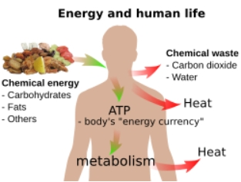
Biology
Image 6
Main articles: Bioenergetics and Food energy
Basic overview of energy and human life
In biology, energy is an attribute of all biological systems, from the biosphere to the smallest living organism. Within an organism, it is responsible for the growth and development of a biological cell or organelle of a biological organism. Energy used in respiration is stored in substances such as carbohydrates (including sugars), lipids, and proteins stored by cells. In human terms, the human equivalent (H-e) (Human energy conversion) indicates, for a given amount of energy expenditure, the relative quantity of energy needed for human metabolism, using as a standard an average human energy expenditure of 6,900 kJ per day and a basal metabolic rate of 80 watts.
For example, if our bodies run (on average) at 80 watts, then a light bulb running at 100 watts runs at 1.25 human equivalents (100 ÷ 80), i.e., 1.25 H-e. For a difficult task of only a few seconds' duration, a person can put out thousands of watts, many times the 746 watts in one official horsepower. For tasks lasting a few minutes, a fit human can generate perhaps 1,000 watts. For an activity that must be sustained for an hour, output drops to around 300; for an activity kept up all day, 150 watts is about the maximum. The human equivalent assists understanding of energy flows in physical and biological systems by expressing energy units in human terms: it provides a "feel" for the use of a given amount of energy.
Sunlight's radiant energy is also captured by plants as chemical potential energy in photosynthesis, when carbon dioxide and water (two low-energy compounds) are converted into carbohydrates, lipids, proteins, and oxygen. Release of the energy stored during photosynthesis as heat or light may be triggered suddenly by a spark in a forest fire, or it may be made available more slowly for animal or human metabolism when organic molecules are ingested, and catabolism is triggered by enzyme action.
All living creatures rely on an external source of energy to be able to grow and reproduce – radiant energy from the Sun in the case of green plants and chemical energy (in some form) in the case of animals. The daily 1500–2000 Calories (6–8 MJ) recommended for a human adult are taken as food molecules, mostly carbohydrates and fats, of which glucose (C6H12O6) and stearin (C57H110O6) are convenient examples. The food molecules are oxidized to carbon dioxide and water in the mitochondria.

Equation 3
Equation 4

And some of the energy is used to convert ADP into ATP:
ADP + HPO42− → ATP + H2O
The rest of the chemical energy of the carbohydrate or fat are converted into heat: the ATP is used as a sort of "energy currency", and some of the chemical energy it contains is used for other metabolisms when ATP reacts with OH groups and eventually splits into ADP and phosphate (at each stage of a metabolic pathway, some chemical energy is converted into heat). Only a tiny fraction of the original chemical energy is used for work:
Gain in kinetic energy of a sprinter during a 100 m race: 4 kJ
gain in gravitational potential energy of a 150 kg weight lifted through 2 metres: 3 kJ daily food intake of a normal adult: 6–8 MJ
Living organisms are remarkably inefficient (in the physical sense) in their use of the energy they receive (chemical or radiant energy); most machines manage higher efficiencies. In growing organisms, the energy that is converted to heat serves a vital purpose, as it allows the organism’s tissue to be highly ordered regarding the molecules it is built from. The second law of thermodynamics states that energy (and matter) tends to become more evenly spread across the universe: to concentrate energy (or matter) in one specific place, it is necessary to spread out a greater amount of energy (like heat) across the remainder of the universe ("the surroundings"). Simpler organisms can achieve higher energy efficiencies than more complex ones, but complex organisms can occupy ecological niches that are not available to their simpler brethren. The conversion of a portion of the chemical energy to heat at each step in a metabolic pathway is the physical reason behind the pyramid of biomass observed in ecology. As an example, to take just the first step in the food chain, of the estimated 124.7 Pg/a of carbon that is fixed by photosynthesis, 64.3 Pg/a (52%) are used for the metabolism of green plants, i.e., reconverted into carbon dioxide and heat.
Earth sciences
In geology, continental drift, mountain ranges, volcanoes, and earthquakes are phenomena that can be explained in terms of energy transformations in the Earth's interior, while meteorological phenomena like wind, rain, hail, snow, lightning, tornadoes and hurricanes are all a result of energy transformations in our atmosphere brought about by solar energy.
Sunlight is the main input to Earth's energy budget, which accounts for its temperature and climate stability. Sunlight may be stored as gravitational potential energy after it strikes the Earth, as (for example, when) water evaporates from oceans and is deposited upon mountains (where, after being released at a hydroelectric dam, it can be used to drive turbines or generators to produce electricity). Sunlight also creates most weather phenomena, saving a few exceptions, like those generated by volcanic events, for example. An example of a solar-mediated weather event is a hurricane, which occurs when large, unstable areas of warm ocean, heated over months, suddenly give up some of their thermal energy to power a few days of violent air movement.
In a slower process, radioactive decay of atoms in the core of the Earth releases heat. This thermal energy drives plate tectonics and may lift mountains via orogenesis. This slow lifting represents a kind of gravitational potential energy storage of thermal energy, which may later be transformed into active kinetic energy during landslides, after a triggering event. Earthquakes also release stored elastic potential energy in rocks, a store that has been produced ultimately from the same radioactive heat sources. Thus, according to present understanding, familiar events such as landslides and earthquakes release energy that has been stored as potential energy in the Earth's gravitational field or elastic strain (mechanical potential energy) in rocks. Before this, they represent the release of energy that has been stored in heavy atoms since the collapse of long-destroyed supernova stars (which created these atoms).
Cosmology
In cosmology and astronomy, the phenomena of stars, novae, supernovae, quasars, and gamma-ray bursts are the universe's highest-output energy transformations of matter. All stellar phenomena (including solar activity) are driven by various kinds of energy transformations. Energy in such transformations is either from gravitational collapse of matter (usually molecular hydrogen) into various classes of astronomical objects (stars, black holes, etc.), or from nuclear fusion (of lighter elements, primarily hydrogen).
The nuclear fusion of hydrogen in the Sun also releases another store of potential energy, which was created at the time of the Big Bang. At that time, according to theory, space expanded, and the universe cooled too rapidly for hydrogen to completely fuse into heavier elements. This means that hydrogen represents a store of potential energy that can be released by fusion. Such a fusion process is triggered by heat and pressure generated from the gravitational collapse of hydrogen clouds when they produce stars, and some of the fusion energy is then transformed into sunlight.
Quantum mechanics
Main article: Energy operator
In quantum mechanics, energy is defined in terms of the energy operator (Hamiltonian) as a time derivative of the wave function. The Schrödinger equation equates the energy operator to the full energy of a particle or a system. Its results can be considered as a definition of the measurement of energy in quantum mechanics. The Schrödinger equation describes the space- and time-dependence of a slowly changing (non-relativistic) wave function of quantum systems. The solution of this equation for a bound system is discrete (a set of permitted states, each characterized by an energy level), which results in the concept of quanta. In the solution of the Schrödinger equation for any oscillator (vibrator) and electromagnetic waves in a vacuum, the resulting energy states are related to the frequency by Planck's relation: E=hν
Equation 5
(where h is the Planck constant and ν the frequency). In the case of an electromagnetic wave, these energy states are called quanta of light or photons.
Relativity
When calculating kinetic energy (work to accelerate a massive body from zero speed to some finite speed) relativistic ally – using Lorentz transformations instead of Newtonian mechanics – Einstein discovered an unexpected by-product of these calculations to be an energy term which does not vanish at zero speed. He called it rest energy: energy which every massive body must possess even when at rest. The amount of energy is directly proportional to the mass of the body: E0 = m0c2, 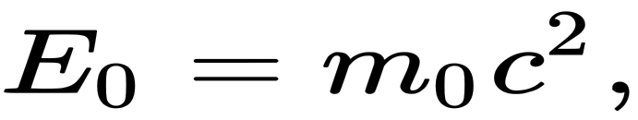
Equation 6
Where m0 is the rest mass of the body, c is the speed of light in a vacuum, E0 is the rest energy. For example, consider electron–positron annihilation, in which the rest energy of these two individual particles (equivalent to their rest mass) is converted to the radiant energy of the photons produced in the process. In this system, the matter and antimatter (electrons and positrons) are destroyed and changed to non-matter (the photons). However, the total mass and total energy do not change during this interaction. The photons each have no rest mass but have radiant energy, which exhibits the same inertia as did the two original particles. This is a reversible process – the inverse process is called pair creation – in which the rest mass of particles is created from the radiant energy of two (or more) annihilating photons.
In general relativity, the stress–energy tensor serves as the source term for the gravitational field, in rough analogy to the way mass serves as the source term in the non-relativistic Newtonian approximation.
Energy and mass are manifestations of one and the same underlying physical property of a system. This property is responsible for the inertia and strength of gravitational interaction of the system ("mass manifestations") and is also responsible for the potential ability of the system to perform work or heating ("energy manifestations"), subject to the limitations of other physical laws.
In classical physics, energy is a scalar quantity, the canonical conjugate to time. In special relativity, energy is also a scalar (although not a Lorentz scalar, but a time component of the energy–momentum 4-vector). In other words, energy is invariant concerning rotations of space, but not invariant concerning rotations of spacetime (= boosts).

Transfer energy:

Energy may be transformed into different forms at various efficiencies. Items that transform between these forms are called transducers. Examples of transducers include a battery (from chemical energy to electric energy), a dam (from gravitational potential energy to kinetic energy of moving water (and the blades of a turbine) and ultimately to electric energy through an electric generator), and a heat engine (from heat to work).
Examples of energy transformation include generating electric energy from heat energy via a steam turbine or lifting an object against gravity using electrical energy driving a crane motor. Lifting against gravity performs mechanical work on the object and stores gravitational potential energy in the object. If the object falls to the ground, gravity does mechanical work on the object, which transforms the potential energy in the gravitational field to the kinetic energy released as heat on impact with the ground. The Sun transforms nuclear potential energy to other forms of energy; its total mass does not decrease due to that itself (since it still contains the same total energy even in different forms), but its mass does decrease when the energy escapes out to its surroundings, largely as radiant energy.
There are strict limits to how efficiently heat can be converted into work in a cyclic process, e.g., in a heat engine, as described by Carnot's theorem and the second law of thermodynamics. However, some energy transformations can be quite efficient. The direction of transformations in energy (what kind of energy is transformed to what other kind) is often determined by entropy (equal energy spread among all available degrees of freedom) considerations. In practice, all energy transformations are permitted on a small scale, but certain larger transformations are not permitted because it is statistically unlikely that energy or matter will randomly move into more concentrated forms or smaller spaces.
Energy transformations in the universe over time are characterized by various kinds of potential energy that have been available since the Big Bang, being "released" (transformed to more active types of energy, such as kinetic or radiant energy) when a triggering mechanism is available. Familiar examples of such processes include nucleosynthesis, a process ultimately using the gravitational potential energy released from the gravitational collapse of supernovae to "store" energy in the creation of heavy isotopes (such as uranium and thorium), and nuclear decay, a process in which energy is released that was originally stored in these heavy elements, before they were incorporated into the Solar System and the Earth. This energy is triggered and released in nuclear fission bombs or civil nuclear power generation. Similarly, in the case of a chemical explosion, potential chemical energy is transformed into kinetic and thermal energy in a very short time.
Yet another example is that of a pendulum. At its highest points the kinetic energy is zero and the gravitational potential energy is at its maximum. At its lowest point the kinetic energy is at its maximum and is equal to the decrease in potential energy. If one (unrealistically) assumes that there is no friction or other losses, the conversion of energy between these processes would be perfect, and the pendulum would continue swinging forever.
Energy is also transferred from potential energy (Ep) to kinetic energy (Ek) and then back to potential energy constantly. This is referred to as conservation of energy. In this isolated system, energy cannot be created or destroyed; therefore, the initial energy and the final energy will be equal. This can be demonstrated by the following:
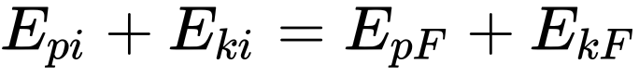  Equation 7 |  | 4
The equation can then be simplified further since Ep=mgh
Equation 8
(mass times acceleration due to gravity times the height) and Ek=12mv2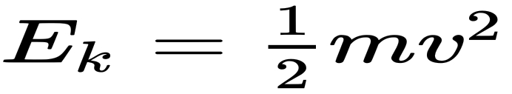
Equation 9
(half mass times velocity squared). Then the total amount of energy can be found by adding Ep+Ek=Etotal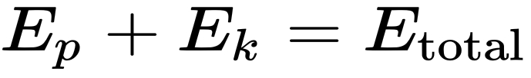
Equation 10
Conservation of energy and mass in transformation
Energy gives rise to weight when it is trapped in a system with zero momentum, where it can be weighed. It is also equivalent to mass, and this mass is always associated with it. Mass is also equivalent to a certain amount of energy, and likewise always appears associated with it, as described in mass–energy equivalence. The formula E = mc2, derived by Albert Einstein (1905), quantifies the relationship between relativistic mass and energy within the concept of special relativity. In different theoretical frameworks, similar formulas were derived by J.J. Thomson (1881), Henri Poincaré (1900), Friedrich Hasenöhrl (1904), and others (see Mass–energy equivalence
#History for further information).
Part of the rest of the energy (equivalent to rest mass) of matter may be converted to other forms of energy (still exhibiting mass), but neither energy nor mass can be destroyed; rather, both remain constant during any process. However, since c2 is extremely large relative to ordinary human scales, the conversion of an everyday amount of rest mass (for example, 1 kg) from rest energy to other forms of energy (such as kinetic energy, thermal energy, or the radiant energy carried by light and other radiation) can liberate tremendous amounts of energy (~ 9×1016 joules, equivalent to 21 megatons of TNT), as can be seen in nuclear reactors and nuclear weapons.
Conversely, the mass equivalent of an everyday amount of energy is minuscule, which is why a loss of energy (loss of mass) from most systems is difficult to measure on a weighing scale, unless the energy loss is very large. Examples of large transformations between rest energy (of matter) and other forms of energy (e.g., kinetic energy into particles with rest mass) are found in nuclear physics and particle physics. Often, however, the complete conversion of matter (such as atoms) to non-matter (such as photons) is forbidden by conservation laws.
Reversible and non-reversible transformations
Thermodynamics divides energy transformation into two kinds: reversible processes and irreversible processes. An irreversible process is one in which energy is dissipated (spread) into empty energy states available in a volume, from which it cannot be recovered into more concentrated forms (fewer quantum states), without degradation of even more energy. A reversible process is one in which this sort of dissipation does not happen. For example, conversion of energy from one type of potential field to another is reversible, as in the pendulum system described above.
In processes where heat is generated, quantum states of lower energy, present as possible excitations in fields between atoms, act as a reservoir for part of the energy, from which it cannot be recovered, to be converted with 100% efficiency into other forms of energy. In this case, the energy must partly stay as thermal energy and cannot be completely recovered as usable energy, except at the price of an increase in some other kind of heat-like increase in disorder in quantum states, in the universe (such as an expansion of matter, or a randomization in a crystal).
As the universe evolves with time, more and more of its energy becomes trapped in irreversible states (i.e., as heat or as other kinds of increases in disorder). This has led to the hypothesis of the inevitable thermodynamic heat death of the universe. In this heat death, the energy of the universe does not change, but the fraction of energy that is available to do work through a heat engine or be transformed to other usable forms of energy (using generators attached to heat engines) continues to decrease.

Conservation of energy
Main article: Conservation of energy
The fact that energy can be neither created nor destroyed is called the law of conservation of energy. In the form of the first law of thermodynamics, this states that a closed system's energy is constant unless energy is transferred in or out as work or heat, and that no energy is lost in transfer. The total inflow of energy into a system must equal the total outflow of energy from the system, plus the change in the energy contained within the system. Whenever one measures (or calculates) the total energy of a system of particles whose interactions do not depend explicitly on time, it is found that the total energy of the system always remains constant.
While heat can always be fully converted into work in a reversible isothermal expansion of an ideal gas, for cyclic processes of practical interest in heat engines, the second law of thermodynamics states that the system doing work always loses some energy as waste heat. This creates a limit to the amount of heat energy that can do work in a cyclic process, a limit called the available energy. Mechanical and other forms of energy can be transformed in the other direction into thermal energy without such limitations. The total energy of a system can be calculated by adding up all forms of energy in the system.
Richard Feynman said during a 1961 lecture:
There is a fact, or if you wish, a law governing all natural phenomena that are known to date. There is no known exception to this law – it is exact so far as we know. The law is called the conservation of energy. It states that there is a certain quantity, which we call energy, that does not change in manifold changes that nature undergoes. That is a most abstract idea, because it is a mathematical principle; it says that there is a numerical quantity which does not change when something happens. It is not a description of a mechanism, or anything concrete; it is just a strange fact that we can calculate some number, and when we finish watching nature go through its tricks and calculate the number again, it is the same.
— The Feynman Lectures on Physics
Most kinds of energy (with gravitational energy being a notable exception) are subject to strict local conservation laws as well. In this case, energy can only be exchanged between adjacent regions of space, and all observers agree as to the volumetric density of energy in any given space. There is also a global law of conservation of energy, stating that the total energy of the universe cannot change; this is a corollary of the local law, but not vice versa.
This law is a fundamental principle of physics. As shown rigorously by Noether's theorem, the conservation of energy is a mathematical consequence of translational symmetry of time, a property of most phenomena below the cosmic scale that makes them independent of their locations on the time coordinate. Put differently, yesterday, today, and tomorrow are physically indistinguishable. This is because energy is the quantity that is canonically conjugated to time. This mathematical entanglement of energy and time also results in the uncertainty principle – it is impossible to define the exact amount of energy during any definite time interval (though this is practically significant only for very short time intervals). The uncertainty principle should not be confused with energy conservation – rather, it provides mathematical limits to which energy can, in principle, be defined and measured.
Each of the basic forces of nature is associated with a different type of potential energy, and all types of potential energy (like all other types of energy) appear as system mass whenever present. For example, a compressed spring will be slightly more massive than before it was compressed. Likewise, whenever energy is transferred between systems by any mechanism, an associated mass is transferred with it.
In quantum mechanics, energy is expressed using the Hamiltonian operator. On any time scale, the uncertainty in the energy is by
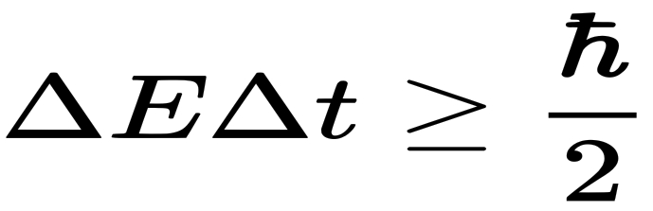
Equation 11

Which is similar in form to the Heisenberg Uncertainty Principle (but not mathematically equivalent thereto, since H and t are not dynamically conjugate variables, neither in classical nor in quantum mechanics).
In particle physics, this inequality permits a qualitative understanding of virtual particles, which carry momentum. The exchange of virtual particles with real particles is responsible for the creation of all known fundamental forces (more accurately known as fundamental interactions). Virtual photons are also responsible for the electrostatic interaction between electric charges (which results in Coulomb's law), for the spontaneous radiative decay of excited atomic and nuclear states, for the Casimir force, for the Van der Waals force, and some other observable phenomena.
Energy transfer
"Energy transfer" redirects here. For the pipeline company, see Energy Transfer Partners.
Closed systems
Energy transfer can be considered for the special case of systems that are closed to transfers of matter. The portion of the energy that is transferred by conservative forces over a distance is measured as the work the source system does on the receiving system. The portion of the energy that does not work during the transfer is called heat. Energy can be transferred between systems in a variety of ways. Examples include the transmission of electromagnetic energy via photons, physical collisions that transfer kinetic energy, tidal interactions, and the conductive transfer of thermal energy.
Energy is strictly conserved and is also locally conserved wherever it can be defined. In thermodynamics, for closed systems, the process of energy transfer is described by the first law:
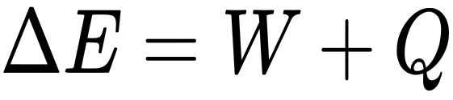
Equation 12
Where E is the amount of energy transferred, W represents the work done on or by the system, and Q represents the heat flow into or out of the system. As a simplification, the heat term, Q, can sometimes be ignored, especially for fast processes involving gases, which are poor conductors of heat, or when the thermal efficiency of the transfer is high. For such adiabatic processes,
This simplified equation is the one used to define the joule, for example.
Open systems
Beyond the constraints of closed systems, open systems can gain or lose energy in association with matter transfer (this process is illustrated by the injection of an air-fuel mixture into a car engine, a system which gains energy thereby, without addition of either work or heat). Denoting this energy by E, one may write.
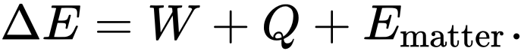  Equation 13 |  | 3
Thermodynamics Internal energy
Internal energy is the sum of all microscopic forms of energy of a system. It is the energy needed to create the system. It is related to potential energy, e.g., molecular structure, crystal structure, and other geometric aspects, as well as the motion of the particles, in the form of kinetic energy. Thermodynamics is chiefly concerned with changes in internal energy and not its absolute value, which is impossible to determine with thermodynamics alone.
First law of thermodynamics
The first law of thermodynamics asserts that the total energy of a system and its surroundings (but not necessarily thermodynamic free energy) is always conserved, and that heat flow is a form of energy transfer. For homogeneous systems, with a well-defined temperature and pressure, a commonly used corollary of the first law is that, for a system subject only to pressure forces and heat transfer (e.g., a cylinder-full of gas) without chemical changes, the differential change in the internal energy of the system (with a gain in energy signified by a positive quantity) is given as
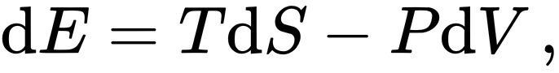
Equation 14

Where the first term on the right is the heat transferred into the system, expressed in terms of temperature T and entropy S (in which entropy increases and its change dS is positive when heat is added to the system), and the last term on the right hand side is identified as work done on the system, where pressure is P and volume V (the negative sign results since compression of the system requires work to be done on it and so the volume change, dV, is negative when work is done on the system).
This equation is highly specific, ignoring all chemical, electrical, nuclear, and gravitational forces, effects such as the advection of any form of energy other than heat and PV-work. The general formulation of the first law (i.e., conservation of energy) is valid even in situations in which the system is not homogeneous. For these cases, the change in internal energy of a closed system is expressed in a general form by

Equation 15

Where δQ is the heat supplied to the system and δW is the work applied to the system.
Equipartition of energy
The energy of a mechanical harmonic oscillator (a mass on a spring) is alternately kinetic and potential. At two points in the oscillation cycle, it is entirely kinetic, and at two points it is entirely potential. Over a whole cycle, or many cycles, average energy is equally split between kinetic and potential. This is an example of the equipartition principle: the total energy of a system with many degrees of freedom is equally split among all available degrees of freedom, on average.
This principle is vitally important to understanding the behavior of a quantity closely related to energy, called entropy. Entropy is a measure of the evenness of a distribution of energy between parts of a system. When an isolated system is given more degrees of freedom (i.e., given new available energy states that are the same as existing states), then total energy spreads over all available degrees equally without distinction between "new" and "old" degrees. This mathematical result is part of the second law of thermodynamics. The second law of thermodynamics is simple only for systems that are near or in a physical equilibrium state. For non-equilibrium systems, the laws governing the systems' behavior are still debatable. One of the guiding principles for these systems is the principle of maximum entropy production. It states that nonequilibrium systems behave in such a way as to maximize their entropy production.

Energy harvesting systems
are the process by which energy is captured from a system's environment and converted into usable electric power.
OR
It’s defined as the conversion of ambient energy into electrical energy.

Energy harvesting allows electronics to operate where there's no conventional power source, eliminating the need to run wires or make frequent visits to replace batteries.
An energy harvesting system generally includes circuitry to charge an energy storage cell and manage the power, providing regulation and protection.
Energy source examples include light (captured by photovoltaic cells), vibration or pressure (captured by a piezoelectric element), temperature differentials (captured by a thermo-electric generator), radio energy (captured by an antenna), and even biochemically produced energy (such as cells that extract energy from blood sugar).

The first definition considers only the transducer technology for energy conversion and assumes that the energy must be converted to electricity. Our definition takes a broader, application-centric view, where the transducer is one component of a complete system that provides power for those niche applications where other sources of energy are unavailable or unsuitable. Ambient energy is all around us, in many different forms – thermal, chemical, electrical, mechanical, and more. To make use of energy harvesting, one or more of these energy fields must be present in the environment of interest, and there must be a suitable transducer to convert the energy. Off-grid energy, Energy harvesting is used where another supply of energy is not available. Harvesters cost money, so it only makes sense to use them when it is too expensive or physically impossible to use other energy sources, such as grid electricity or batteries. On-demand energy. An energy harvester has to supply power when it is needed, not simply when it is available, and some form of energy storage is generally required to match the demand with the supply.

How much energy is available?
There are, in principle, many different energy fields available from which to harvest energy:
• Radiation (light, solar, cosmic rays, electromagnetic radiation)
• Thermal
• Mechanical (potential, kinetic, elastic, fluid)
• Gravitational
• Chemical (battery, fuel cell, fossil fuels, phase change)
• Nuclear
• Magnetic (Magnetization, currents, etc.)
• Electric. In practice, many have no value for energy harvesting. Sound, cosmic radiation, atmospheric pressure variation, and nuclear background radiation are universally present, but have almost no associated energy.

Whether the other energy fields are usable depends entirely on the location of the harvester, and the list of useful energy types usually comes down to only one or two that are suitable for a given application in each location. Outdoors, above ground, sunlight is a good source of energy with high energy density and good predictability. Wind can be suitable for large enough applications that are high enough to provide clear airpaths. Suitable temperature differences and vibrations are hard to find. Indoors, artificial lighting can provide enough power for low-power applications, such as calculators, but most other fields are not present or do not provide enough energy. For vehicles and industrial applications, machine vibrations and thermal gradients are often practical, since there are high temperatures and strong vibrations at known frequencies. Human motion can be usefully harvested. Commercial products include the wind-up radios, torches, and phone chargers produced by Freeplay and others, and bicycle-powered computing.
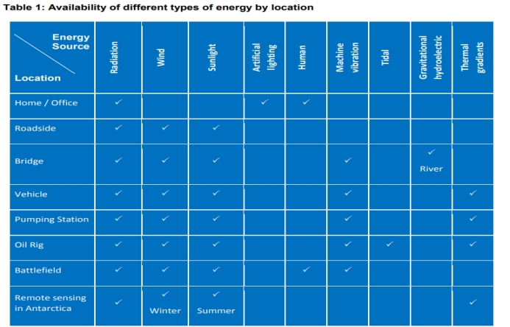
Back-of-the-envelope calculations are the starting point for evaluating whether a particular energy type can ever provide enough power to be useful.
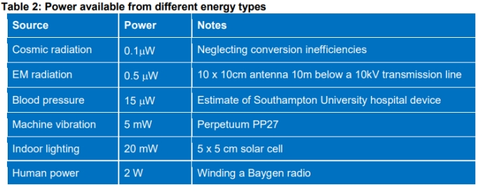
How much energy is needed?
Different kinds of devices have very different energy requirements. A pacemaker requires only around five Joules of energy to operate for a day, whereas a desktop computer requires around 5 Megajoules – a million times more. Some devices operate continuously, and the average power requirement is the same as the instantaneous power requirement. Other devices only need to operate intermittently – something that is on for 1 second, and then off for 9 seconds has a ‘duty cycle’ of 10%, and the average power requirement is thus only 10% of the maximum power requirement. Whether or not a particular application can make use of energy harvesting depends on understanding its energy usage profile and matching it with the energy available from harvesting. The table below gives figures for the energy and power requirements of a range of common devices.
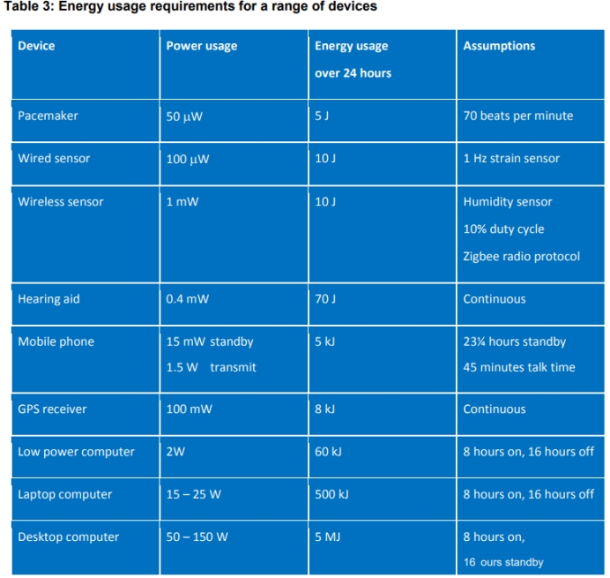
Energy harvesting – a great solution. Energy harvesting is useful when:
• There is a match between the available energy and the energy needed
• Energy harvesting provides a benefit that is not achievable using batteries or grid electricity. Industrial condition monitoring. At a large oil pumping station, there are thousands of pieces of vibrating machinery. Knowing the operating conditions prevents failures and downtime, increases performance, and reduces costs. Wired sensor networks with miles of cabling can be expensive to install, and regular battery replacement for thousands of sensors is possibly even more expensive. A network of autonomous vibration-powered, wireless sensors provides a “fit and forget” solution to the problem of data collection. Powering remote infrastructure. A bus stop becomes more useful with an electronic bus information display. In remote areas, the information is even more useful, but grid electricity is expensive to install because of the distance, and single-use batteries wouldn’t last very long. A generator would be noisy and need to be maintained. The most economical way to power the display and associated electronics is a solar panel and/or small wind turbine, together with a rechargeable battery and power management electronics.
Wireless sensor networks Sensors rarely need much energy, so that readings of flow rate, temperature, humidity, and pressure can be taken with small amounts of harvested energy. Transmitting those readings with newly developed efficient wireless communication protocols then allows that information to be used to save money by early diagnosis of problems and planned maintenance.
Wireless tire pressure sensors. Monitoring tire pressure allows for reduced fuel consumption and safer driving, but there’s no route for power cables from the battery to the tires. Battery-powered sensors with wireless data transmission don’t last long enough, so introduce a maintenance overhead for battery changing. Vibration energy harvesting from the regular impacts as the wheel rotates provides the best solution for powering the sensors.

Pipeline actuators. In an industrial gas pipeline or a steam pipe distribution system, plenty of energy is available. Thermal energy can be harvested using maintenance-free solid-state thermoelectric transducers. The energy can be used to open and close valves without the need to run cabling to the actuators. Other suitable applications:
• Road/rail side traffic signs and monitoring using solar panels and wind turbines
• Remote environmental sensing
• Wind scoop on a lorry to provide autonomous container tracking
• Self-powered wireless light switch for retrofit dimming without rewiring or battery replacement
• Solar-powered mobile phone base station in Africa
• Keeping batteries topped up on small boats

AFTER ALL OF THAT: When does the energy harvesting make sense:-
harvesting energy available.
It is difficult to install power devices.
It is difficult to reach the device for maintenance.
Cords are too costly.
Numerous devices.
Environmentally friendly required.
High uptime demanded

Free energy often comes at a cost, and thinking through the complete system is key to determining whether energy harvesting is going to solve your power needs. Green energy. A myth that keeps cropping up is that energy harvesting is a small-scale demonstration of how we can collect freely available energy in the environment, and that in the future, these same technologies will be scaled up and used to power our homes and businesses. This is false. Except for photovoltaic cells for collecting sunlight, the technologies are completely different.

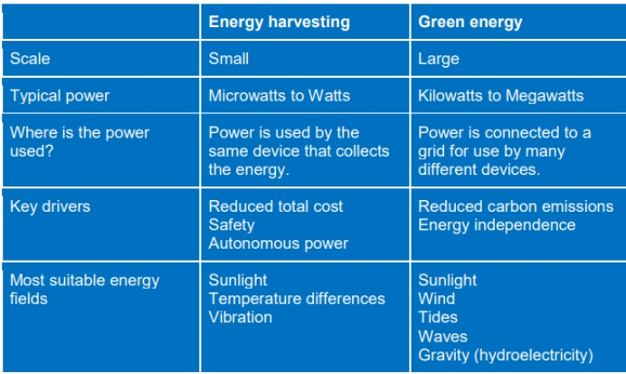
Table 4: comparison between energy harvesting resources

Collecting wastes energy. It’s easy to do calculations showing how much energy is ‘wasted’ by the footsteps of a thousand people, but there’s no business sense in powering ticket machines from the footsteps of commuters at underground stations. The harvesters will be expensive, and the amount of energy that can be collected is trivial in comparison to the energy used in lighting, heating, and ventilation. If cost savings are the goal, then optimizing the operation of the existing building infrastructure and replacing the old plant will pay much sooner. Self-charging consumer electronics. A mobile phone that does not need charging would be wonderful, but we’re unlikely to see one anytime soon, despite increasingly common press releases to the contrary. Existing pocket-sized solar chargers will take a day to charge a standard phone, and you can’t keep your phone in your pocket while it’s charging. Vibration energy harvesters that exploit energy from walking can provide enough power for charging, but only while walking, and are not small enough to be integrated within the phone. Completing these limitations with the increased power consumption of smartphones compared to older phones, and the gap between the energy needed and the energy available is only increasing. Extending device operating time. Our batteries don’t last long enough. How about using energy harvesting to keep them topped up when the power runs out? In our experience, this rarely works out. For an application where you can harvest energy faster than you use it, you don’t need the battery in the first place and can rely entirely on energy harvesting. For an application where you use energy faster than you can harvest it, adding a harvester will only increase the lifetime of your device by a small fraction, e.g., 10% rather than the factor of two or more that you’re looking for. Drop-in battery replacement. A battery-powered device works wherever it is. Harvesters can only provide power when there’s an appropriate energy field. Batteries are mature, low-cost commodity items available from many suppliers. Energy harvesters are currently immature, high-cost, and often bespoke power solutions available from a small number of suppliers.

How does the energy harvest work?
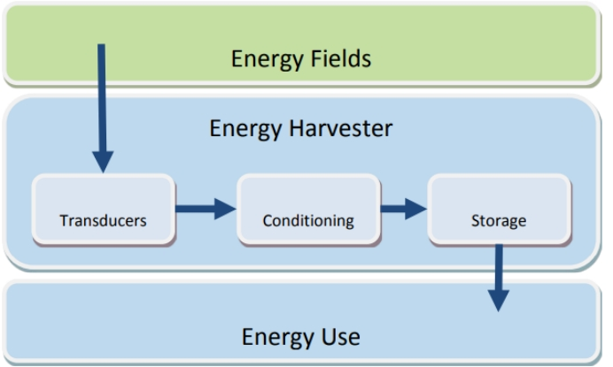
Figure 4: the diagram of energy harvesting procedures

An energy harvester comprises one or more transducers, power conditioning, and energy storage. These technologies work together to collect energy and deliver power to the device. The transducer converts energy from one energy type to a second energy type, usually electricity.

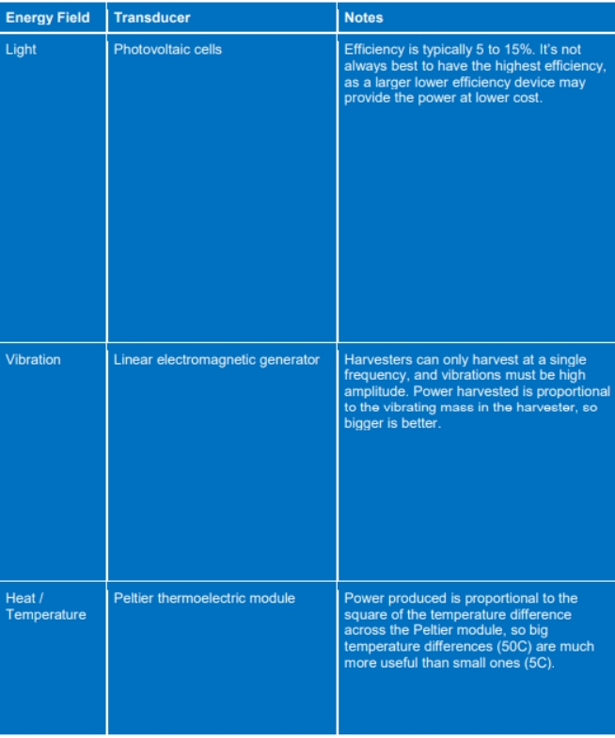
Table 5: Energy fields and transducers

Power conditioning is necessary because the natural output of the transducer can be intermittent, and at the wrong frequency, voltage, and current to directly drive the device. A specialized DC-DC converter microchip takes in power from the transducer and outputs typically 3 to 5V, which can then be stored or used. The converter is an integral part of the system and requires careful electronic design to minimize power losses. Energy storage is needed to balance the energy supply and energy demand. For applications where energy is used as soon as it is collected (e.g., RFID and wireless light switches), no storage is needed. Usually, however, a rechargeable battery, capacitor, or supercapacitor is used. Batteries degrade over time, and so the lifetime of the storage device can often be the limiting factor in the overall lifetime of the harvester. The device that uses energy needs to be designed to work with energy harvesting as the power source. This entails reducing the power requirement to the absolute minimum necessary.

What is the future for energy harvesting?
Much of the effort in energy harvesting has focused on the transducer, to determine how to obtain as much energy as possible from a given energy field. As technology matures the focus will shift to the new applications enabled by energy harvesters.

System integration Plug and play energy harvesting will become the norm. In place of buying each component of the harvester and having to integrate them for each application, we are beginning to see manufacturers and consortia such the EnOcean group designing complete systems which allow a range of different harvesters (solar, vibration, heat) to be connected to common energy conditioning and storage units.

Low power electronics will enable applications that were previously out of bounds. Large microelectronics companies such as Texas Instruments are developing specialized power conditioning chips that minimise power losses and make it easier for energy harvesting to be used as a source of power.

Low power wireless communications protocols that are explicitly designed to minimize the energy required to transmit data are being developed. Their deployment is hindered by the understandable nervousness in committing to technologies which may fall by the wayside in the competition for the best protocols. In time a consensus will emerge.
Smart cities Energy harvesting powered wireless sensors will become ubiquitous, providing ever more valuable information that is used to enable improvements to transport, health, and infrastructure.

Biological systems Power from breathing or blood pressure could power ultra-low power medical implants. Researchers at Southampton University hospital have developed an experimental pacemaker that can draw 1/3 of the power it requires from blood flow.

Falling costs, the cost of energy harvesting will fall dramatically if it makes its way into mass market consumer applications. Then it will be possible for industry applications to make wider use of energy harvesting enabled devices by piggy backing on the development work of others.

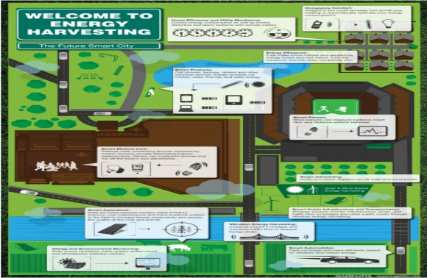
Image 7

after all of that energy harvesting methods:
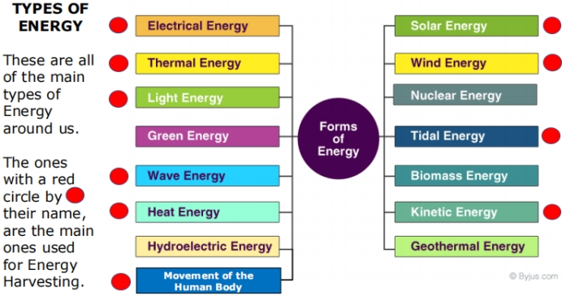
Figure 6: Types of energy harvesting energy

The sun is the main source of energy and the reasonable of every life bieg through the earth.

Coal

Advantages
Coal can be found in lots of places in the world and there are still plenty in the UK.
Coal can be easily transported to power stations.
Coal is a relatively cheap energy source.

Disadvantages
To dig up coal, we must create mines which can be dangerous and not very nice to look at.
Transporting coal by lorry and train from the mine to the power station causes pollution.
Burning coal produces polluting gases like Sulphur dioxide which make acid rain.
Of all energy sources, burning coal releases the most greenhouse gases which may add to
global warming.
Coal is a non-renewable source and will run out in about 100 years.
Coal miners can be affected by black lung disease or pneumoconiosis and also emphysema if
they breathe in too much of the coal dust.

Oil and Natural Gas

Advantages
Oil and natural gas are found in lots of places in the world.
We can transport oil and gas in pipes and by using tankers or ships.

Disadvantages
Environmental damage can be caused when building the rig and by accidental oil spillages.
Oil and gas are not renewable, so once the supplies are used, they will run out.
Burning these fuels releases greenhouse gases into the air. This may add to global warming.
The price of oil and gas will increase because supplies are running out and lots of people will
want it
Working on an oil or gas rig can be dangerous due to the risk of explosions and bad weather.

Nuclear

Advantages
Nuclear fuel does not make harmful greenhouse gases.
You only need a very small amount of nuclear fuel to make a lot of energy

Disadvantages
The waste that is produced when using nuclear fuel is radioactive and very harmful. It needs
to be disposed of carefully
Nuclear power stations are at risk from terrorist attack and sabotage.
World uranium supplies may run out in about 50 years.

Wind

Advantages
Wind is free and will not run out so the cost is in building the wind turbine.
Wind power generation does not create greenhouse gases
There are very few safety risks with wind turbines.

Disadvantages
We can only use windmills in areas where there is a lot of wind. Sometimes there may be days
where there is little wind.
We need a lot of turbines to make a lot of electricity.
Some people don’t like the way wind turbines look; they think they spoil the countryside.

Wave

Advantages
Waves are free and will not run out, so the cost is in building the power station.
Wave power does not produce greenhouse gases.
There are very few safety risks with wave power generation.

Disadvantages
Waves can be big or small so you may not always be able to generate electricity.
You need to find a way of transporting electricity from the sea onto the land.
Not many people have tried to generate electricity this way yet so the equipment is expensive.

Tidal

Advantages
Tides are free once the power station has been built and will not run out.
No greenhouse gases are produced when we make electricity.
We know exactly when the tides will happen so we know when electricity will be made.

Disadvantages
You may need to build a large wall called a dam to make the water flow through the generators. This may not be good for plants and animals that live nearby.
The tides only happen twice a day, so they can only produce electricity for that time.

Geothermal

Advantages
Geothermal energy does not produce greenhouse gases
The energy source is free and will not run out

Disadvantages
There are not many places where we can build geothermal power stations
Harmful gases and minerals may occasionally come up from the ground below. These can be
difficult to control.

Solar

Advantages
The energy from the Sun is free.
The sun does not produce greenhouse gases.
The sun will always be there during our lifetime.

Disadvantages
It is relatively expensive to build solar power stations.
When it is cloudy or at night there is not enough light so no electricity can be made.
Some people don’t like the look of solar panels.

Biomass

Advantages
The fuel is cheap and can use things that we might otherwise throw away.
We can find waste everywhere and should not run out.

Disadvantages
When the fuel is burned greenhouse gases are made which pollute the environment.
Sometimes people grow biomass crops where we could grow food.
We may not have enough space to grow enough biomass fuel.

Hydro-electric

Advantages
When the electricity is generated, no greenhouse gases are made.
The water used is free.
It is a renewable energy source.

Disadvantages
The dam is expensive to build.
By building a dam, the nearby area must be flooded, and this could affect nearby wildlife and plants.
If it does not rain much, we may not have enough water to turn the turbines


THE ELECTRIC sensors:
Image 8

A sensor is a device that measures physical input from its environment and converts it into data that can be interrupted by either a human or a machine. Or A sensor is a device that detects the change in the environment and responds to some output on the other system. A sensor converts a physical phenomenon into a measurable analog voltage (or sometimes a digital signal) converted into a human-readable display or transmitted for reading or further processing.
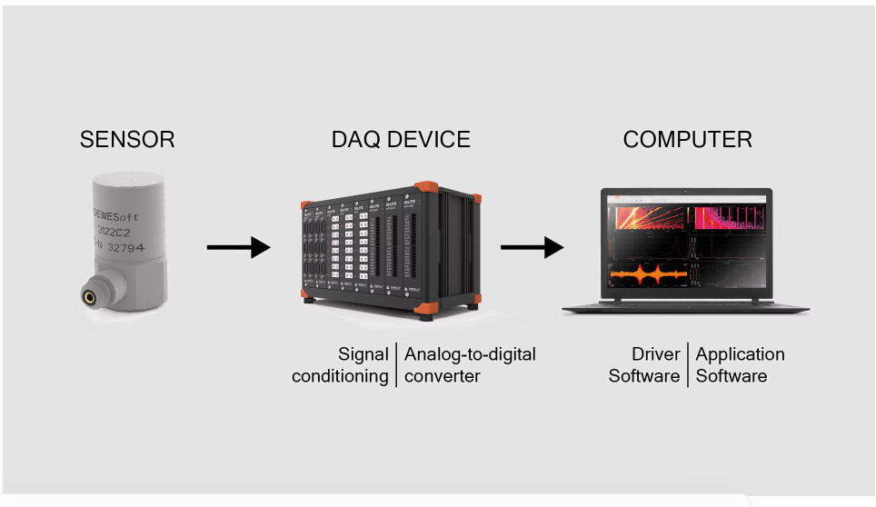
Image 9
Sensors are part of everyday life at home & work. That properly not day goes by you are impacted in some way to that sensor
A sensor is a device that senses something. sensors can see, feel, hear, smell, and even taste. Without sensors, our home and work lives would be quite difficult. For example, as you drive to work, the traffic lights at an intersection are controlled by sensors embedded in the road. These sensors detect your arrival at the intersection. As you approach the grocery store, the door automatically opens because of a sensor. In your plant, the batch process temperature and pressure are displayed and controlled because of output from sensors.

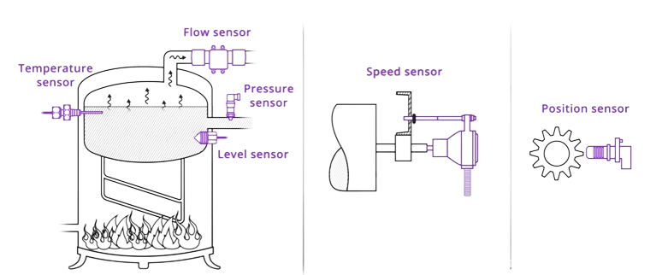
In the world of instrumentation and process control, we define a sensor as a device that detects changes in physical, electrical, or chemical properties and produces an electrical output in response to that change. What are the typical physical properties that sensors are detecting? Let's name a few:
Image 10
◎Level ◎Temperature ◎Flow ◎Pressure ◎Speed ◎Position

From a process control perspective, we can classify sensors as either passive or active. A passive sensor requires an external source of power to operate, while an active sensor does not. A thermocouple is an active sensor, as it does not require any external power supply to operate. As a thermocouple is exposed to an increase in temperature, it will develop an increasing voltage across it. Another example of an active sensor is a piezoelectric sensor.

A resistance temperature detector, or RTD, is a passive sensor. It is a device that's resistance will change with a change in temperature. To take advantage of this change in resistance, an external supply, or an excitation circuit, is required to produce a change in voltage. Another example of a passive sensor is a strain gauge.

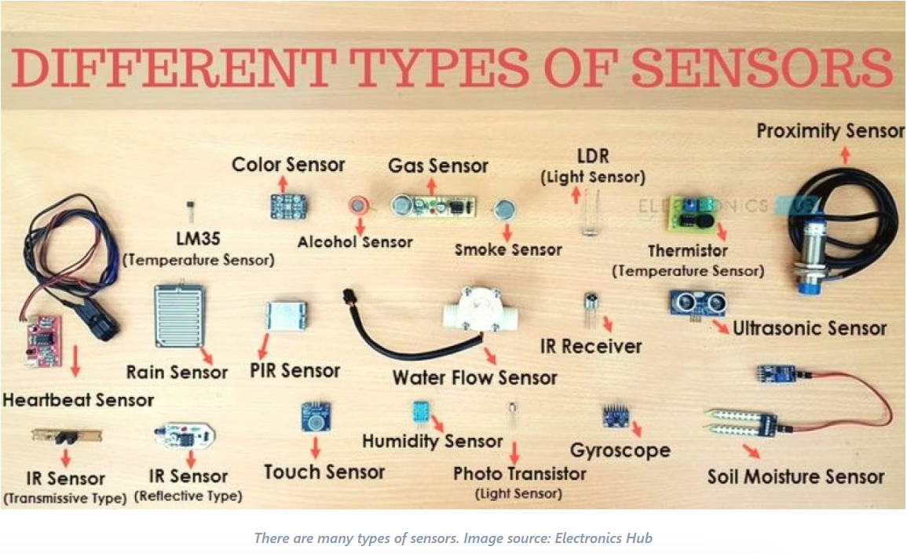
Alright, now that we've talked about sensors and the physical properties that they can sense, let's discuss how they are used in the industry. Almost every sensor used in process control will be connected to a transmitter, because a sensor's output needs to be conditioned or amplified. Here's an example. We've already talked about a thermocouple and the voltage output created when it is heated. Unfortunately, the voltage output of a thermocouple is minuscule. In our example, the thermocouple will produce a voltage output from 8 millivolts to 18 millivolts over a 450-degree Fahrenheit change in temperature. In process control, we condition that 8 millivolts to 18 millivolts thermocouple voltage and convert it to 4 milliamps to 20 milliamps industry standard signal that represents our controlled temperature range.
Image 11

Electronic sensors can detect everything from light to distance to acceleration. Sensors are how a product senses anything in the real world, and there is an almost endless array of them available. Sensors measure real-world quantities, which are then converted into an electrical signal. Actuators, on the other hand, take an electrical signal and convert it into a physical form. For example, motors and speakers are two of the most basic types of actuators. There is such a huge variety of sensors that it

Analog vs Digital:
There are many ways to categorize sensors. One of the most basic ways is analog versus digital. The difference between analog and digital sensors relates to how the sensor outputs the measured data. It rarely has anything to do with the sensing mechanism itself (motor encoders being a notable exception).
For example, many sensors provide a voltage that varies proportionately with the quantity being measured. This voltage is an analog signal that varies continuously between two voltage thresholds.
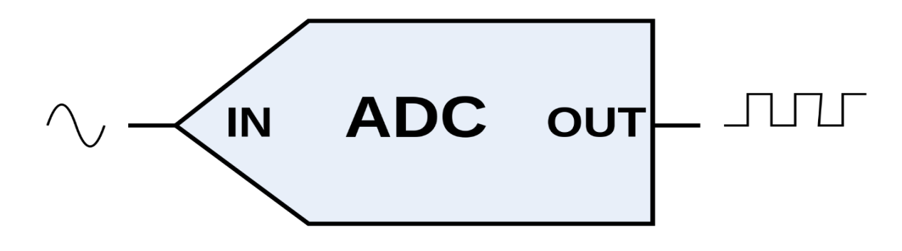
Figure 6: An Analog-to-Digital Converter (ADC) takes an analog input and outputs a digital signal.

When that analog voltage is fed into an analog-to-digital converter (ADC) it will be converted into a digital signal. If this ADC is built into the sensor itself then that sensor is digital. Digital sensors are usually preferable if their price and specifications are acceptable. This is because digital sensors are less susceptible to electrical interference, and they have a lower design risk.
A multimeter is a multi-functional electronic device that can be used to measure parameters such as resistance, voltage, electric current, and frequency in various circuits as well as electronic components. Since multimeters can measure these parameters may also be known as a volt-ohm meter or volt-ohm-milliammeter.

Greases

Greases colors aren't just for appearance; they indicate specific uses:

Red grease withstands high temperatures, making it ideal for heavy machinery.

Blue grease is water-resistant, perfect for marine and outdoor use.

Green grease is common in agricultural equipment.

White grease is food-grade and non-toxic.

Yellow or brown grease is general purpose, often used in automotive and industrial settings.

Each color ensures the right grease for the job.

diesel engine

Diesel engines use compression ignition instead of spark ignition, which is a characteristic of internal combustion engines. They compress the air to a high pressure and temperature, which causes the diesel fuel that sprayed to ignite spontaneously. Most diesel engines follow a four-stroke cycle that consists of the following operations - intake (only with air), compression, power (injection of fuel and combustion), and exhaust.
This lean burn process gives diesel engines superior thermal efficiency, often up to 55% in large engines, making them more fuel-efficient than gasoline engines. Other key features include high compression ratios (14:1 and 23:1), direct fuel injection at high pressure, and torque control by varying fuel quantity instead of throttling air.
The combustion process in diesel engines is not controlled by spark plugs; instead, glow plugs are used for cold starts. Diffusion-controlled combustion is where the fuel and air mix are performing the burning that affects emissions and flame behavior. Turbocharging and intercooling are the techniques used most of the time to increase power and efficiency.
There are three common categories of diesel engines, which are high-speed (over 1000 rpm) for cars and trucks, medium-speed (300–1000 rpm) for locomotives and ships, and slow-speed (below 300 rpm) for large marine engines. There are also two-stroke and four-stroke designs, with two-stroke designs mostly being used in very large engines.
Additional advantages of the diesel engine are that it has greater fuel efficiency, is more durable, and has stronger/torquier torque. For heavy-duty applications, diesel engines are ideal. Diesel fuel has high energy content but also requires a high cetane number for good ignition quality.
All in all, diesel engines work by compressing air to light the fuel, which is highly efficient, dependable, and powerful. They find a broad application in the sectors of transportation, industry, and marine, and are often turbocharged and use sophisticated fuel injection methods to match the performance and emission

energy storgement:

Energy storage can be defined as a process in which energy can be stored after being produced all at once. This process helps in maintaining the balance of the supply and demand of energy, where energy is transformed from it is difficult matter to store into a form that can be kept affordably for later use. This process can be different according to the shelf-life of energy, or in other words the life of energy that can be stored into the storage system before transforming to another type of energy, this time could be short or long depending on the system in which the energy has been stored through. Mainly there are five types of storage systems:

1. Thermal Energy
2. Mechanical Energy
3. Chemical Energy
4. Electrochemical Energy
5. Solar Energy Storage

Thermal Energy Storage
Thermal Energy Storage (TES) systems are pivotal in improving energy efficiency and flexibility across various sectors. By storing thermal energy--either as heat or cold--for later use. The Types of TES varies as following Sensible Heat Storage involves storing thermal energy by raising the temperature of a solid or liquid without changing its phase. Using materials such as water, sand or even rocks Latent Heat Storage
Latent heat is the energy absorbed or released by a material during a
phase change, such as melting, evaporation or even freezing, All of that
happens using PCMs materials that are special substances to store or release
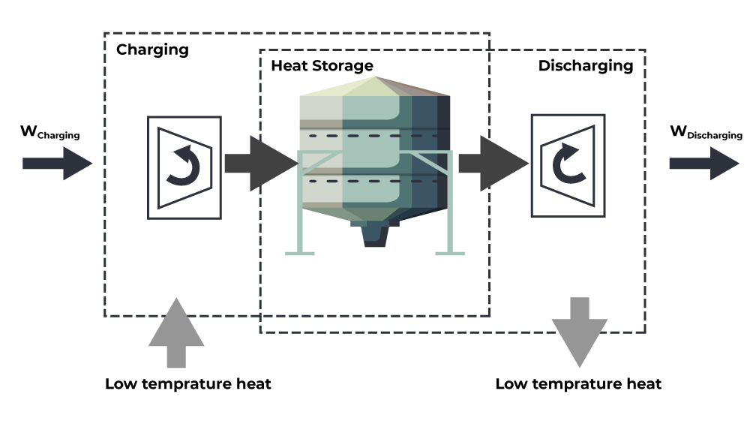
energy when they change their physical state such as paraffin wax (solid <--
Image 12
> liquid), slat hydrates or Ice
Thermochemical Storage
The Thermochemical storage uses the heat caused by chemical reactions,
This process is called reversible chemical reactions to store and release
energy, offering high storage capacity and long-term energy retention
1 / 6Thermal Energy Storage Systems has many applications, but a common one used is a Carnot Battery as shown in Fig.01 The way that the Carnot battery works is easy, first it uses thermal energy storage to store electrical energy, and then, during charging of this battery electrical energy is converted into heat and then it is stored as heat. Now, once you
want to use the battery when it starts the
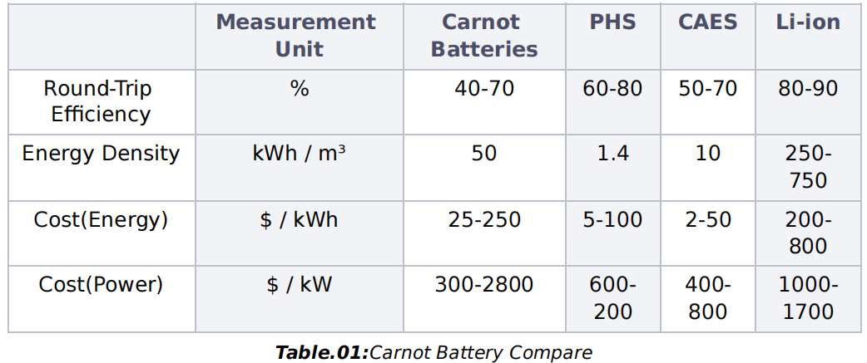
The discharging process in which the heat that was previously stored will be converted back into electricity, quite a simple way of storing energy but it shows great results compared to many storage solutions cost-wise as shown in Table.01.
The Efficiency of the Carnot Batteries may be the lowest due it could easily use any heat which means loses energy, but when it comes to the cost of storing energy as shown in the table it is very low compared to PHS (Pumped Hydro Storage) or even the highest of them Li ion(Lithium-ion Batteries), but when it comes to the cost of producing the energy that it has been storing the Carnot Batteries is the cheapest option to go for.

Mechanical Storage

It's a way to store Energy Using motion instead of chemical reactions (like batteries), involving Kinetic Energy and Potential Energy.
Instead of storing electricity directly (like a battery), it converts electricity into motion or stored pressure and then backs into electricity when needed.

There are many types of mechanical storage, but those are the most used:
Flywheels
A heavy wheel spins at a high speed to store energy, then whenever
Electricity is needed, the wheel slows down, and by that motion its energy is converted back into electricity. To prevent energy loss, it is kept in a vacuum with magnetic levitation to reduce friction. This could be used in hospitals and data centers to back up power. Compressed Air Energy Storage (CAES) Uses compressed air to store energy in underground caverns or tanks, then the air is released to turn into a turbine that generates power using the momentum of the air the turbine turns fast and generates enough power. There are three types
◎Diabatic (releases heat during compression)
◎Adiabatic (stores heat to improve efficiency)
◎Isothermal (minimizes heat loss for better performance)
This is used in air drills or paint atomizers
◎Pumped Hydro Storage (Gravitational Potential Energy)
You could describe this as a big water battery using two water reservoirs at different heights, when the energy is available, water is pumped up to the higher reservoir then when energy is needed the water flows down, spinning turbines to generate electricity This system could be merged with another harvesting system to be a great renewable energy storage to store extra energy from solar, wind etc.

The use of mechanical storage instead of batteries is more suitable due to its longer lifespan that could last for decades and its high efficiency especially when using flywheels, and it is more sustainable, as it doesn't require any toxic chemicals like lithium batteries, but each type of mechanical energy storage has its advantages and disadvantages as shown in Table.02
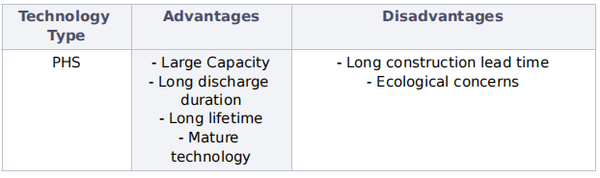
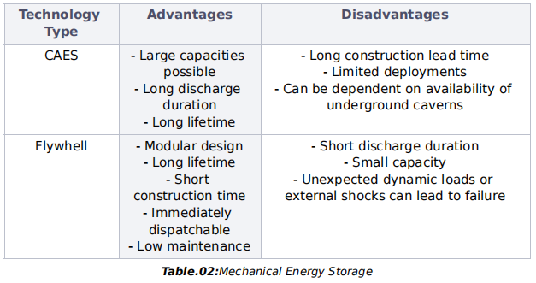

as shown in the table every type has some killer disadvantages, but after
analyzing the data as shown in Table.03, it could be told that the best type is flywheel, as it have the most efficiency but it have very short discharge duration and small energy capacity, so the best type that combines between efficiency and energy capacity is the PHS where it have efficiency of 70-85% and an energy capacity of a maximum 5,000 MWh
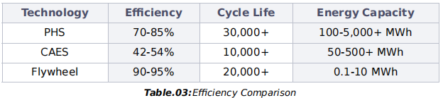

Chemical Energy Storage
Chemical storage refers to storing chemicals or energy in a chemical form that can be used later, these chemicals might be hazardous or non-hazardous. When it comes to energy systems, chemical storage focuses on storing energy sources like biomass, coal, and gas for the future.
It has many applications in the real world such as electric vehicles that store chemical energy in batteries for driving or mobile devices that store energy in batteries for phones, laptops, and other gadgets that use lithium-ion batteries. Biofuel storage involves storing energy derived from organic matter. Including plants, waste from homes, industries or agriculture, and it is considered renewable since they come from organic sources and can replace fossil fuels. As it could produce enough energy for small and large generators. Hydrogen storage involves storing hydrogen as a form of a fuel, these systems can maintain low temperatures to keep hydrogen in liquid form and uses high
pressure tanks to compress hydrogen gas. Later it could be used as clean fuel for vehicles, such as hydrogen-powered cars and buses, with no harm to the environment as it only emits water after being used as fuel. Providing a way to store renewable energy like solar or wind power, which could be converted to hydrogen through electrolysis.

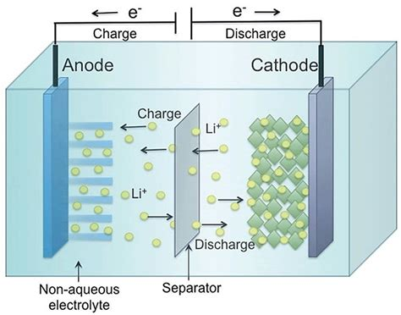
Electrochemical Storage
Image 13
Electrochemical Storage of energy in a chemical form that can be converted to electricity when needed. This storage method provides high energy density (how much energy is stored) and power density (how quickly the energy can be delivered), by making applications that require long-term, efficient storage. This method could be used in portable devices such as mobiles, computers and music players or electric vehicles and even renewable energy systems to store wind-based electricity, for instance. Batteries are an application of electrochemical storage, which is a storage device made up of a cathode (positive terminal) and an anode (negative terminal). These are separated by an electrolyte that facilitates the flow of ions during charging and discharging, batteries are widely used in the world from the portable electronics to the energy systems.
The applications vary from the static random-access memory (SRAM), or lifts, even the automobiles use it for power boosts.

Table.04 compares supercapacitor and batteries in detail
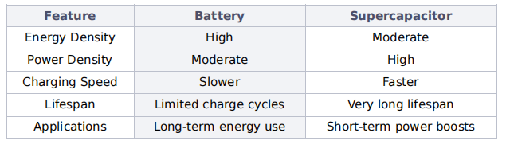
Table 4: Comparing supercapacitor and batteries in detail

Solar Energy Storage
Storing solar energy for later use without using any electricity, it just uses natural sources to operate various devices, vehicles and many more is known as solar energy storage. Solar fuels can be manufactured and stored in compounds of ammonia, hydrogen, and hydrazine when there is no sunlight. They are portable or transportable and can be used over a long period, this could be applied in separating water into hydrogen and oxygen, cooking food, and creating clean and efficient energy

Other solutions already tried
While researching the solution and its efficiency, and how it would be applied, some prior solutions must be taken into consideration, storage system solution and the harvesting system solution.

Storage system one:

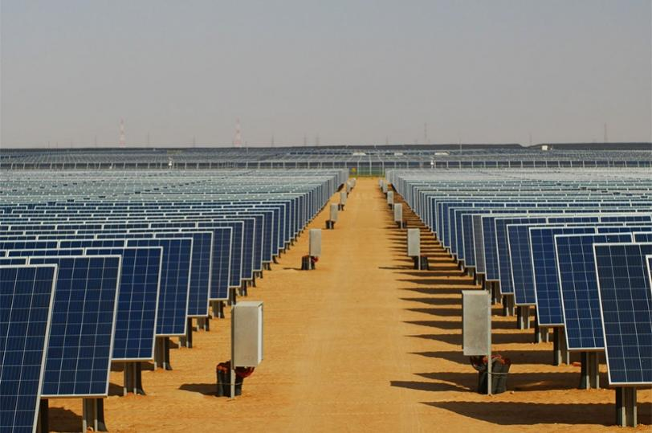
Benban solar park
Image 14

Egypt geographically is located between latitudes (22 and 31.5 north) and that made it is located at the heart of global solar belt so that Benban solar park in Aswan one of the most important projects in Egypt that use to produce energy and storage it.

Using solar energy to produce and storage energy:
Benban solar park is a park that Built on an area of 250 thousand acres, and it contains about 200 thousand solar panels that used to produce and storage about 50 megawatts of clean energy, enough to light 70,000 homes and that makes it the largest solar energy station in the world.

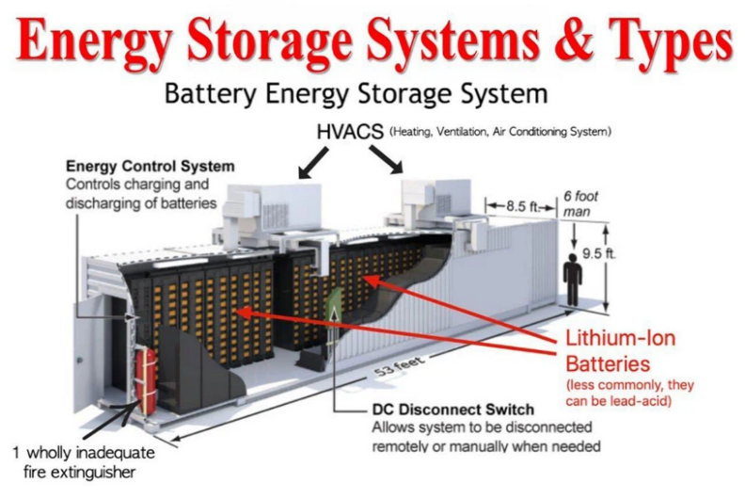
Battery energy storage systems (BESS) is the storage system that used in ben ban solar park and it used because it has many advantages such as that it is increasing efficiency of renewable energy because solar and wind produce intermittent energy and that means they can’t produce energy consistently through the day so that this system allows energy to be stored during the time of high production of energy and released during low production and that maximizing the utilization of renewable sources so that this advantage make the energy is used even the source is not active like the sun at night. It also an environmental benefit as BESS is often used to storage a renewable energy it reduces harms of fossil fuels for energy production and that leads to lower greenhouse gas emissions and smaller carbon footprint and that solve one of the Egypt grand challenges by increase the pollution. BESS also has many advantages so that we used it in Benban park.
Image 15

How this storage system works
BESS it is a lithium-ion batteries and these batteries store excess energy generated by solar panels or wind turbines. Batteries are discharged to release power when needed, such as during peak demand, power outages, or grid balancing.

Harvesting systems:

Zafarana wind farm

Overview:
In early 1980s, the Egyptian Ministry of Electricity and Energy formulated its national strategy in the field of New and Renewable Sources of Energy (NRSE). The strategy targeted to supply 5% of the country’s total primary needs, from NRSE by the year 2005. Priority has been given to wind, solar energy and biomass.

Egypt exploited wind energy and searched for the best windy areas Moreover, the North Coast of Egypt, South Sinai, East Oweinat and Gelf Ridge, enjoy high potentials for wind energy investments. The Red Sea Coast at Zafarana was selected for the establishment of large-scale wind farms.

The first large-scale wind farm was built in Egypt in 2000/2001. The wind farm is erected in one of the windiest sites in this part of the world, where the average wind speed exceeds 9 m/sec. The location is 120 km South of Suez on the Red Sea.

Zafarana wind farm is a wind power plant located in Ras Gharib it consists of eight wind farms over an area round of 12 X 18 km. it is the first wind turbine in Egypt and it is one of the most important place to produce energy and it produces third of energy that high dam produce . it built in 8 phase from 2000 to 2010 and is the second largest farm in East Africa after Gabel El Zeit Wind farm . El zafarana farm has 700 wind turbines and it produces energy from different ways.

Advantages:
- Renewable energy: the wind is a sustainable resource unlike natural gas, oil and coal. The zafarana farm has a total capacity of around 545 MW, making it one of Egypt’s largest wind power projects

- Environmental benefits: the wind is nature and renewable resources on the other hand (oil, gas and coal) all of them are harmful for the environment when they burn it produces co2 that pollute the environment.

- Cost-Effective Energy Production: all the renewable energy has a low cost because when humans do it still works automatically.

- Job Creation & Economic Growth: Thousands of jobs were created during the construction and operation phases.

- Supports Egypt’s Energy Goals: its terms of Egypt aim to produce 42% electricity from renewable energy sources before 2036 and it encourage Egypt to get rid of the nonrenewable and polluted source.

Disadvantages:

- Energy storage limitation: as there is no large-scale battery storage to store the excess wind energy for use
- Dependency on Foreign Technology: Most wind turbines and components are imported, leading to higher costs and dependence on international supplies
- 3- Shorter Lifespan Compared to Other Power Plants: as Wind turbines typically last 20-25 years, whereas fossil fuel or nuclear plants can operate for 40-60 years.

The high Dam in Egypt

Overview:
The High Dam is in the south of Egypt on the Nile River specifically in Aswan. It is one of the most important projects in the country. It was built between 1960 and 1970 with the property of controlling floods. It provides hydroelectricity generating and ensures regular irrigation for agriculture.

Mechanism:
The High Dam has a height of 111 meters, length of 3,830 meters and hydroelectric capacity of 2.1 GW from 12 turbines. It works by controlling the flow of the Nile River, regulating the flow of the water, generating hydroelectricity and preventing the floods.

Points of strength:
- Hydroelectric power generation
- Regular water supplies
- Flood controlling
- Economic benefits
- Water storage

Points of weakness:
- High evaporation loss
- Soil fertility loss
- Environmental impacts
- Sediments accumulation

Finally, there is one point that should be illustrated at every point throughout science, or even in the projects, and the inventions, too. All are like steps on building the renaissance, like a brick in the architecture, and that an Honor to us to be the builders of the new cultures with an invention, aspiring architects going forward to build not a normal building but a skyscraper that hits the clouds.

CHAPTER I I

Generating and Defending a Solution:

Solution and Design Requirements
The Design requirement is made to better visualize the qualitative proprieties likes the efficiency, safety, friendly in using, eco -friendly, durability of structures (sustainability), as a cost-effective system, etc… and quantitative properties like speed thought producing energy, overall volume of the project, forces which will act on it.

In any project there are types of design requirement):
- - general design) solution requirement).
- - project’s specific requirement.

General design requirements [solution requirement]):

They are the main design requirements, their presence principal for ensure of the project efficiency, usability, effective and success, for instance):

#Environmentally friendly)-
The project's benefits are determined by its ability to have an environmental impact. Almost all the grand challenges are based on negative environmental consequences. We were able to accomplish this by reusing recycled materials to make clean energy instead of the desirable harmful types of energy.
As an eco-friendly project, we have two main effective points that will make the hybrid Savonius wind turbine more friendly to the environment:

Using waste materials that will be recycled like:
- old plastic (to form the plates of the wind turbine and to be in electrical insulation)

- old types of metals like copper which will be recycled from old will used in the wires by that the cost will decrease too

3)old generator and AC to DC converter with some editing on both

2 - Generating clean renewable energy from unconventional resources, not as result in environmental deficiencies which is not desirable. Without generating any harmful gases or radiation or thing else which will harm the environment.

There wouldn’t any environment deficiencies (harmfully effect will be exposed to the environment) will be happen on total because of the two last points.

#Cost-effective system)-
The cost of every project is an essential factor in determining its quality. The price distinguishes the project from others that perform the same function and address the same problem, so we resorted to implementing the following procedures to ensure the low-cost high quality in an effective and smart way:

Since all the materials used are recycled, then they will be with low cost with the same efficiency of the new ones (every piece would be used in the project) as we have edited on it, like (removing the rust from them to ensure their sustainability and strength by using advanced technological technics and also knowledge in chemistry) and all of that to ensure that the cost will be one of the pros of the project, so it will be available in everywhere.
2-Idea of complex design which will is an incredible advantage as our design will used less materials, surely by that the cost will decrease too much.

#Availability)-
The prototype's cost, safety when managing it, and application availability are all determined by the materials chosen to build it. Local, cost-effective materials should be employed to achieve this purpose.
So, we decided to use old plastic, garbage and mechanical old pieces and their other components due to their low cost and effectiveness after editing

#Safety)-
The project must be safety to all who are exposed to be nearby from the wind turbine as a non-impediment project to ensure the achievement and following the precautions to detect that’s everything is perfect, so it can be friendly used in a sample way too.

#User friendly)-
The high safety which in the project with the respect of the incredible mixture between the complex of the design related the sampling in the mechanism of energy harvesting and storagment from the hybrid Savonius wind turbine turns this project easy to use with all the securities which makes it User friendly.

#Sustainable design and materials)-
The design, construction method, and the materials used. All that must be sustainable and have enough strength to get away for a long time without any deficiencies.

#Real life application)-
One of the most important notes that must be taken in the consideration the project to be applicable not only theoretical but also in the real life like it must be suitable to the place where is it and matches the surrounding environment too.

Project’s specific requirements [design REQUIREMENT]:

#Adaption within climate change)-
The uncertainty and climatological dependency of most renewable energy sources mandates the application of energy storage systems that work in a time of deficiency.

#The volume of the prototype)-
The volume of the prototype mustn’t be exceeded 0.5 m3, in other words the area of the base which is the length multiplied by width all multiplied by the height not more than 0.5 m3 (L×W×H ≤ 0.5 m3).

#The produced energy)-
The requirement of the project is to have the ability to generate an amount of energy of 0.4kw/sec. Which equals producing 40 watts of power throughout 5 minutes maximum
〖The output energy (E_{output})－the input energy (E_{input})[in 5 minutes] ≥ 40 watt〗
Equation 16

#The energy storagment)-
- In case of using the fluids in general as a method of storagment as a compressed fluid, the pressure doesn’t exceed 2 bars which is equals to (2 × 105 N/M2).

- Electrical insulation must be taken into consideration as a principal and fundamental condition to ensure safety.

- An implement a simple and measurable storage system for the electricity that is produced.

Selection of Solution
Egypt suffers from the problems of Egyptian lack of renewable energy, that in-turn compels people to utilize non-renewable sources, which would be more harmful regarding environmental aspects. Thus, finding a solution that would generate electricity from a renewable source like wind would make a great impact on our society and environment. Moreover, constructing our solution will reduce greatly the percentage of plastic as the solution would be built from plastics and recycled materials as well as locally grown waste material.

Our solution for this problem in this capstone project is to reduce the using of non-renewable energy which reassess harmful gases that causes global warming That is a harmful impact that results in very harmful effects reaching the destruction of the environment of it hasn’t taken in consideration which will causes climate change due that the harmful impact will propagate through the all the chains of ecosystem and all of that by generating an non contagious energy from wind turbine actually hybrid Savonius one and that’s will change the impact into positive one to rescue our dear earth. The reasons of choosing vertical hybrid Savonius wind turbine because it collects air from everywhere and it aligned with aerodynamics instead of others forms and types of wind turbine and it generates much more energy

Several ways and methods could be applied to achieve our goal. However, developing a solution for this problem was regarding efficiency, availability, scalability, and applicability.

Location:
Our wind turbine aims to be in place which a have a good weather to applies enough force and that’s by presence of high velocity as the force of wind produced from wind turbine is directly proportional to the wind velocity, so that the choose of the place must following the recruitment without forget the ability of wind turbine to resist the forces of wind gravitational and also the centripetal one due the movement of the plate of the wind turbine00.

Our solution materials suitability:

A hybrid Savonius wind turbine will be our idea, which will generate about 40 watts or more, and to generate this amount this requires some requirements and procedures, like the selection of material,

the plates of plastic using the blower as a source of wind force to make the plates rotate to have a light weight which will facilitate its movement and its speed by that this kinematic force change into electric one by a generator of 240V
So that the energy produced increased, and another point too it has light wight so that it will be better for the sustainability and the equilibrium of the whole project.

The bar in the middle of the turbine which is made of iron is made of strong material to ensure the presence of high-tension force during the handle of plates and generator is higher than that of centripetal forces, gravitational, and wind forces too

And finally, we make sure that every part of the machinery parts and construction parts are sustainable for both the design of the aerodynamic and to the requirement electricity production goal

As the using the wind turbine specially the hybrid Savonius wind turbine needs specially precautions in the designing and in the construction like that the tension force between the recycled iron bar to the plates must be higher that the centripetal force that’s generated due the movement of the plates to ensure that the strength of the construction and not to escape with higher escaping acceleration as we can say (tension force > centripetal force ), not that only the net force must be greater than ZERO (the tension is the greater ), because the wind force must take in the consideration and shouldn’t neglect it,
since the wind force which equals
(V² × p × A × C × 0.5 = F), and knowing that
◎The average wind(V) speed in Ismailia is 10Km/h.
◎The exerted force on area about the area of every plate of the type multiply the area of the plate plus the n of the Savonius plate multiply their area (n* Savonius plates ×the area of plate ＋ n* H plates × the area of plate)
◎The {p} is related to density of the air; however, the average density of the air is 1.225kg/m³
◎C is coefficient of value equals 1.2
By that the wind force calculated, then the tension force must be greater than centripetal force + the wind force, without forgetting of the effect of the gravity = 9.8 m²/sec, and knowing that the force equals mass multiply acceleration

To sum up one of the most important designs recruitments is that [F_{T} ≥ ΣF_{r} + F_{w}+F_{g}]

Solution mechanism and procedures:

-The wind follows using wind blower of 6m3/sec. That generates a force of
36 × 1.225 × A × 1.2 × 0.5 = F on the plates specially will be perpendicular to each curved part of it making the plates rotate

Since the omega = v.r, omega is the rotations of the plates per second, V is the velocity of plates , and R is the radius

Then the Kinetic energy = 0.5.m. v2

And this converted to electric by generator to watt measured and measured by multimeter

Selection of prototype
During the selection of the prototype, it must be ensured that the prototype will meet the design requirements “using volume less than 0.5 $m^{3}$, generating 40 KWs in 5 minutes, and making sure that the prototype will achieve the constancy of the high efficiency over long periods of time”.

The prototype:

The “hybrid H-Savonius VAWT”, it is a combination between the H-type Darrieus VAWT and the Savonius VAWT. The H-type Darrieus VAWT is highly efficient in high wind speeds but struggles with self-starting at low wind speeds, on the other hand, the Savonius turbines excel in self-starting, but it has low efficiency in high wind speeds.
To overcome these limitations, the hybrid H-Savonius VAWT was made to combine the advantages of both H-type Darrieus and Savonius turbines to achieve high efficiency, self-starting capability, and generating energy in various wind conditions, then store it in Lithium Batteries which have high efficiency and long lifespan.

Constructing the prototype:

Firstly, a wood stick of 40 cm length and 1.5 cm width was bought. A bucket cover was hollowed in the middle and got into the stick then they were glued by the fast glue. After that, a bucket was cut into two halves, and the lowest part was used as a base for the prototype. The Savonius part was made of a big water bottle then it was glued to bucket cover on the stick, then three plastic straight blades were made and glued between the two covers of the bucket to present the H-typed VAWT. After that a generator was connected to the lower part of the stick under the hollowed part of the bucket then it was connected to lithium battery.

Chapter I I I

Constructing

and Testing

a Prototype :

Materials & Methods
items | image | usage | cost
2 Wooden sticks |  | To stabilize the prototype | 45
2 Bucket |  | the base of prototype | recycled
2 Wheel bearing |  | It helps the movement of the wooden stick | 40
Plastic Water tank | 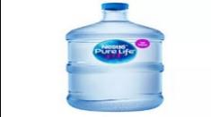 | It makes by it the blades of the turbine | recycled
3 Lithium-ion battery |  | Responsible for storage  energy | 35
generator | 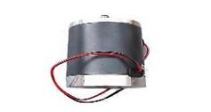 | Generation electricity | 250
2 gears |  | Increase RPM | 75
Table 6: the material used during the construction of prototype
*The prototype was carried out as follows:
1- a frame in the shape of circular base that is made of bucket and the design of turbine, and dimensions of the prototype was taken.
2 the plastic water tank was cut, as blades to the turbine, and then it stabilized on the wooden stick.
3- A circular hole was opened in the base and the bearing was stabilized in this hole, after that the wooden stick was put in the hole of the wheel bearing.
4 then the big gear was stabilized in the wooden stick, under the base of the prototype, and was then connected to the small gear, to turn the generator.
5- then the wires of the generator were connected to the charging module
6- the charging module was then connected to the batteries.

- Calculate the electric current and the voltage to get the wattage in 3 trials using a multimeter and AVO meter to test the energy generated per 5 minutes (amperes × volts).
- The battery is used to store the generated electricity and is used easily in many applications that give the ability to use the stored electricity at any time
- The efficiency was calculated to know the percentage of the mechanical energy of wind into electric energy by using the law of efficiency, which is (output\input) *100

Test plan
After finishing the prototype, the next step is to evaluate it to know if the expected results have been achieved or not, the prototype must follow those design requirements

Design requirements

- The Turbine must produce 0.04Kws in at most 5 minutes.
- The Turbine must be less than 0.5m3 in volume
- The prototype must be less than 5kg
- The turbine must start at low win speeds
- The turbine blades must withstand high wind speeds
- the turbine must operate properly for long time without blade corruption
- The prototype must store energy in batteries

- so, a few tests were then done, to validate the design requirements

Power Generation test

- the generator of the turbine was connected to a multimeter
- then it measured OHM or resistance of the circuit
- then it measured the voltage
- then the peak and the lowest volt reading was taking to get the average volt
- then the power was then calculated to be V2 / R
- The power was then measured over 300 seconds

Dimensions Test

- The length, width and height of the prototype was measured three times
- then an average of the three trails was chosen
- the volume of the prototype was calculated

C. Weight Test

- The prototype is weight measured three times
- the average weight of the prototype was than taking

D. Self-start test

- The turbine was put into a closed room and was low wind speed
- Then it was observed for a course of 10 minutes to determine whether it could start or not

E. High-wind speed test

- a simulation with a blower was done on the prototype
- for 20 minutes at the maximum blower speed
- the blades were then observed whether there is corruption or not

F. Long-time test

- The turbine was put outside for a course of 1 hour
- then the blades were observed whether it is corrupted or not

G. battery test

- The turbine was put into a simulation with a wind blower
- the output voltage and current were measured by a multimeter
- then the generator was connected to the lithium batteries
- the batteries were then tested to determine whether it is charged or not

Data collection
After constructing the prototype and doing the test plan, a wind blower of speed 3 $m^{3}$/min was used to make the test for the prototype. After testing the prototype, the table of results was calculated.

Time (s) | Voltage (V) | Resistance ($Ω$) | Power (W)
1st minute | 5.571 $±$ 0.58 | 99.1 $±$ 0.1 | 0.313 $±$ 0.07
2nd minute | 5.891 $±$ 0.58 | 99.1 $±$ 0.1 | 0.350 $±$ 0.07
3rd minute | 7.034 $±$ 0.58 | 99.1 $±$ 0.1 | 0.499 $±$ 0.07
4th minute | 6.752 $±$ 0.58 | 99.1 $±$ 0.1 | 0.460 $±$ 0.07
5th minute | 7.129 $±$ 0.58 | 99.1 $±$ 0.1 | 0.513$±$ 0.07
Table 7: The results of testing prototype.
Tool | Image | Usage
Wind blower |  | It was used as a source of wind to make the test
Multimeter |  | It was used to measure the output of the test
Vernier caliper | 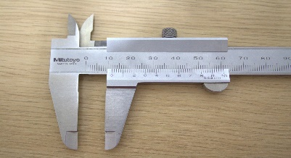 | It was used to measure the lengths and radiuses of the prototype
Protractor |  | It was used to measure the angles and curves of the prototype
Meter | 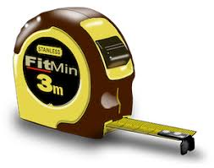 | It was used to measure the lengths of the large parts of the prototype as the large stick
Table 8: the tool used through the test plan.

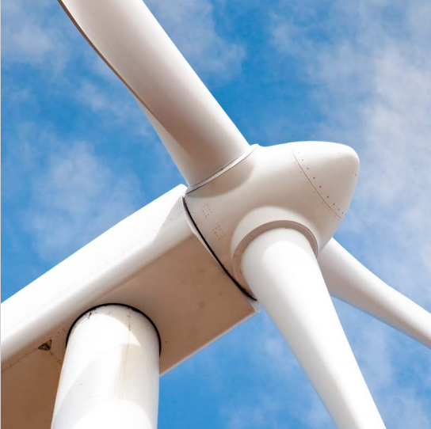

Chapter I V.

Evaluation, Reflection, Recommendations:

Analysis and Discussion
1- Gears

Gears are rotating machine elements, with teeth that connect and mesh into each other to transmit the torque and rotational motion. They enable control over power, speed, and torque. To understand how gears work together and function, we first must look at gear components.

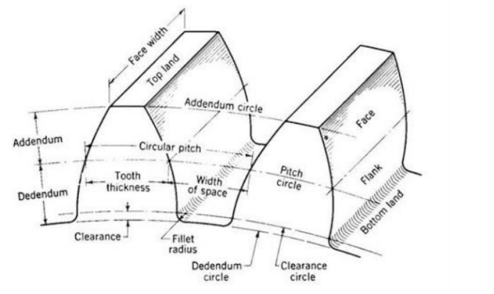
As shown in the opposite figure, gears have multiple components, this is called the gear nomenclature, those are the most important when buying a gear.
Figure 7: gear nomenclature

- Face Width: the length of gear in the axial direction
- Pitch Circle: an imaginary circle on a gear where two gears roll together without slipping
- Tooth Thickness: it is the width of the tooth at pitch circle diameter
- Pressure Angle: the angle between gear center line and a line perpendicular to the line of action, and generally it is set to 14.5, 20, 22.5 or 25 depending on the gear itself.

There are some rules that will help when dealing with gears, and will ensure a constant and reliable gear system, the most important one is the law of gearing.

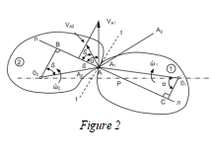
Firstly, the law of gearing, which states that for two gears to mesh without any slipping and move smoothly, the common normal, which is the line perpendicular to the contacting tooth surfaces, must always pass through a fixed point on the line of centers called the pitch point. As shown in the opposite figure.
Figure 8: the law of gearing

It is easier to describe this law mathematically than with states.

Let two gears, first gear is rotating from the center O₁ and the second gear is rotating from the center O₂, then at any instant their teeth contact at point A, then the tangent line that is tangent on this point A is called t, then draw a line perpendicular on this tangent line and name it common normal or n, then by assuming that those two gears have no slipping at contact point, and they have smooth motion, this result a two equal velocity components along the common tangent or t as following:
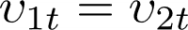

This is only on the tangent line, but the velocities on the common line can differ, Let P be the point where the common line intersects the line of the two centers O₁O₂, so now the tangential velocities at points C and B relative to the two centers will be equal to the following:

where and are the angles of pressures, then according to the equation above the two velocities are equal assuming those gears are not slipping then the equation will be:

then the angle of each cos will equal the following based on the triangles in the diagram:

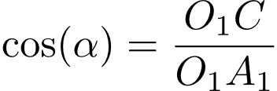

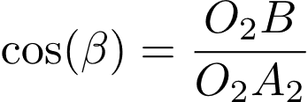
then plug these into the last equation, then the terms will cancel each other getting us to the final equation by the last step.

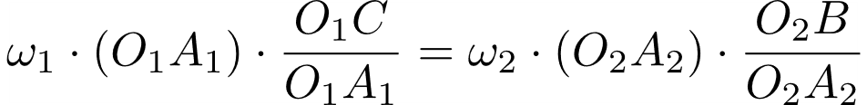

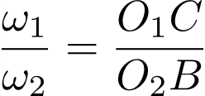

this law is then used as a fundamental law for many laws in gears, one of which was used in this project, which was the gear ratio law, which is used to control whether the system is used to produce higher torque or higher speed as follows:

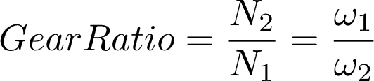

where N is the number of teeth in the gear, in this project, the law was used to produce higher speed, which means that the number of teeth in the first gear should be bigger than the second gear, so for this project as the wind turbine rotates about x per minute and the generator needs about x rpm, to reach the maximum voltage production, substituting in the equation have gave a gear ratio about x:x

Recommendations
As is known, as humans nothing always becomes 100% perfect, but there is always room for improvement, so there are some recommendations to improve our project in terms of large scale, prototype and suggestions:

Recommendations of large scale:

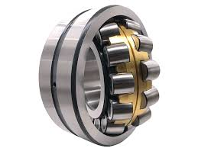
- Using Spherical Roller Bearings (SRBs) because it is the best type that match with savonius wind turbine in terms of having high load capacity and durability that match with the harsh environment (dust, rain and temperature environment) and it easy to be fixed.
Image 16

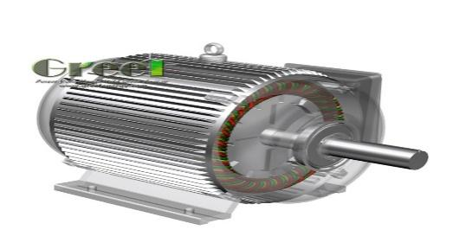
- Using Permanent Magnet Synchronous Generator (PMSG), this type of generator is the best type that matches with the savonius turbine because it solves a lot of demerits of the savonius such as it works well at low speed, and it Converts wind energy to electricity very efficiently and it does not need gearbox in special cases.
Image 17

- Using a sensor to regulate a speed when the speed of wind reaches to maximum speed of the blades.

- Improve the curve of the blades and using a plastic has a low weight and high strength like carbon fiber or reinforced composites.
- Add Guide Vanes / Flow Deflectors because it Directs wind more efficiently into the concave part of the blades and Can increase power output by 20-30%.

Recommendations for prototype
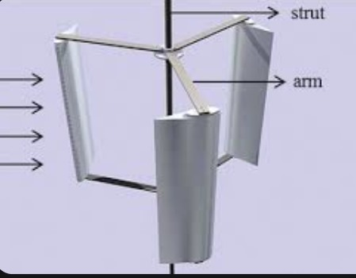
Image 18
- put the (H-DARRIES) wind turbine to help the savonius wind turbine to collect the air to increase the speed of turbine, decrease the inertia of the turbine and increase the efficiency of the turbine

- Increase the volume of the blades in savonius because when the volume increases the turbine collects a big amount of wind, the speed increases and finally get high power.

Recommendation of suggestion

Recommendation for another team that wants to continue working on our solution:
1. Benefit from the learning outcomes that will be learned to achieve the best function of the capstone project.
2. Commit to safety rules during work in the capstone or more specifically the construction of the prototype
3. Avoid searching for project-related information on untrusted sites and sources like (.com) as the information that they contain isn’t 100% accurate and even if it was it is too risky to base the project on information that may or may not be true.

Learning outcomes

LO. | Connection & relation
Ph.1.09 | To measure the flow of air throughout the turbine and how turbulent flow causes on the plates.
Me.1.06 | Calculate the resultant force and resolve it too, and the usage of Lami’s rule.
Me.1.07 | To calculate the net force on the turbine from all directions also understand the friction as concept in real life application.
Me.1.08 | Add forces as vectors and determine an objects acceleration) or lack of acceleration).
Me.1.09 | Calculate acceleration, velocity during circular motion, and application of the concepts: centripetal acceleration and centripetal force.
Ma.1.07 | Interpret the functions based on the real  world situation they model.
Ma.1.08 | Use different properties of exponential function in graph to illustrate the amount of generated energy through amount of time.
Ma.1.09 | Modelling with trigonometric functions.
ES.1.08 | Different earth materials and ore minerals have different chemical, physical and engineering properties making them suitable for different economic industries, and Modern electronics technologies require new materials, such as rare earth elements, that must  also be extracted from earth materials, creating new ores and new industries.
ES.1.10 | What resources could be developed in Egypt to provide more sources of energy.
CH.1.08 | Know the physical properties and where those materials can be used.
CH.1.14 | Examine a variety of commercial batteries and use their understanding of electrochemistry to explain how they work and why the manufacturers used the materials they did, and how to design our own battery.
BI.1.15 | Analyze the unbalanced Egypt ecosystem to suggest the effective solution.

List of Sources in APA Format

(citations)

Lakeh, H. (2024, March 27). What are the Pros and Cons of Renewable Energy? Www.greenmatch.co.uk. https://www.greenmatch.co.uk/blog/2021/09/advantages-and-disadvantages-of-renewable-energy

Ritchie, H., Roser, M., & Rosado, P. (2023). Energy. Our World in Data.
https://ourworldindata.org/energy

Union of Concerned Scientists. (2017, December 20). Barriers to Renewable Energy Technologies. Union of Concerned Scientists. https://www.ucsusa.org/resources/barriers-renewable-energy-technologies

Miller, B. (2020, February 21). 21 Advantages and Disadvantages of Non-Renewable Energy. Green Garage.
https://greengarageblog.org/21-advantages-and-disadvantages-of-non-renewable-energy

International Trade Administration . (2021, September 5). Egypt - Information and Communications Technology; and Digital Economy | International Trade Administration. Www.trade.gov. https://www.trade.gov/country-commercial-guides/egypt-information-and-communications-technology-and-digital-economy

Ritchie, H., Roser, M., & Rosado, P. (2020). CO₂ and greenhouse gas emissions. Our World in Data, from:
https://ourworldindata.org/co2-and-greenhouse-gas-emissions

Client Earth. (2025, March 27). Fossil Fuels and Climate Change: The Facts. Client Earth.
https://www.clientearth.org/latest/news/fossil-fuels-and-climate-change-the-facts/

United Nations. (2025). Causes and Effects of Climate Change. United Nations; United Nations. https://www.un.org/en/climatechange/science/causes-effects-climate-change

Atlas Scientific. (2023, November 10). 7 Effects Of Water Pollution. Atlas Scientific.
https://atlas-scientific.com/blog/effects-of-water-pollution/

Denchak, M. (2023b). Water Pollution: Everything You Need to Know. NRDC.
https://www.nrdc.org/stories/water-pollution-everything-you-need-know#effects

Agency, C. I. (2022, November 29). Egypt. CIA.gov; Central Intelligence Agency.

https://www.cia.gov/the-world factbook/countries/egypt/#energy

